Vision-Language Transformers for Automated Medical Report Generation from Brain CT Scans

Porthamarai Chandrta mohan

Abstract
The growing pressure on use of diagnostic imaging, the worldwide shortage of radiologists has revealed the eminent necessity to have automated systems which may help in clinical reporting. Computed tomography (CT) scans of the brain are essential in the diagnosis of life-threatening neurological diseases, such as stroke, hemorrhage and trauma. The interpretation of these images and the subsequent generation of detailed radiology reports however, is still a labor-intensive, time-consuming and inter-observer variant process. This dissertation has addressed these issues by coming up with the vision-language transformer model that can automatically produce structured diagnostic reports based on brain CT scans.
The system proposed utilizes modern architecture like BLIP-2 and ViLT that combine visual and textual modalities to facilitate an image-to-language translation process. Another significant innovation in this project is the use of synthetic diagnostic text, which was produced using large language models, as a solution to the problem of a limited number of paired CT report datasets due to privacy and availability concerns. Fine-tuning transformer-based models are based on the resulting multimodal dataset which consists of real and synthetic pairs. The explainability tools (Grad-CAM) are also used to add more features to the system, by visualizing the CT areas that have the greatest impact on the reports generated, which in turn facilitates clinical trust and interpretability.
The final deliverable will consist of a prepared dataset, a low-loss vision-language model, a scan-to-end report-generation system, a user interface to upload scans, and both qualitative and quantitative (using natural language metrics) and clinical relevance measures. The project would foster scalability, interpretability, and efficiency to minimize reporting delays, assist radiologists in decision-making, and improve patient outcomes, especially in healthcare environments with limited resources.

Acknowledgements
Thanks to my Supervisor: Mr. Paul Bombo — Senior Lecturer; Course Leader, Academic guidance and encouragement from the School of Architecture Computer Science and Engineeringand my Family and friends for their patience, support, and motivation throughout this project.

Contents
Contents

Abstract ii
Acknowledgements iii
Supervisor: Mr. Paul Bombo — Senior Lecturer; Course Leader, BSc/BA Computer Science with Education and QTS; School of Computer Science and Digital Technologies. Academic guidance and encouragement from the School of Computer Science and Digital Technologies. Family and friends for their patience, support, and motivation throughout this project. iii
Contents iv
List of Tables vi
List of Figures vii
List of Acronyms viii
Chapter 1 1
Introduction 1
  - Background 2
  - Problem Statement 4
  - Research Question and Objectives 6
  - Expected outcomes 10
Chapter 2 13
Literature Review/Related Work 13
  - Comprehensive Overview of the Existing Literature 13
  - Critical Analysis of Existing Studies 17
Chapter 3 22
Methodology 22
  - System architecture and pipeline overview 23
  - Data collection and organisation 24
  - Preprocessing and dataset manifest 25
  - Paired text construction via synthetic reports 26
  - Feature Extraction and Selection 26
  - Model development 27
    - Model choices and motivation 27
    - Tokenisation and inputs 27
    - Training objective and schedules 27
    - 2.5D context 28
  - Explainability: visual evidence maps for generated text 28
  - Evaluation protocol 28
    - Textual metrics 29
    - Clinically grounded checks 29
    - Optional classification metrics 29
    - Automatic text metrics 29
    - Clinically grounded checks 30
    - Human utility 30
    - Optional proxy classification 30
    - Baselines, ablations, and fairness 30
  - Implementation details and reproducibility 30
  - Risks, limitations, and mitigations 31
  - Summary 32
Chapter 4 32
Experimental Results 32
  - Experimental Setup 32
  - Dataset Description 33
  - Evaluation Protocol 34
  - Results (RQ1: Effectiveness of Vision–Language Models) 35
  - Utility of Synthetic Data (RQ2) 36
  - Explainability and Trust (RQ3) 36
  - Baseline and Design Ablations 37
  - Error Analysis 37
  - Optional Proxy Classification 38
  - Limitations 39
  - Summary of Findings 39
Chapter 5 Conclusion and Future Work 40
  - Conclusion 40
  - Future Work 42
References 54
Appendix A. implementation 56
Appendix B. UI element prediction 57

List of Tables

Table1.1 — Research Questions, Metrics, and Ablations

Table 3.1— Literature Overview (ViLT, BLIP-2, InstructBLIP)

Table 4.1 — Main text metrics (BLEU, ROUGE-L, BERTScore-F1)

List of Figures

Figure 1.3: Project scope at the intersection of VLMs, synthetic data, and explainability.
Figure 3.1 Architecture of the proposed system8
Figure 3.3: Class distribution across Normal, Bleeding, and Ischemia

Figure 4.1 — Representative brain-CT slices by class
Figure 4.1b — Additional dataset exemplars across cranial levels Figure 4.2 — Text generation metrics
Figure 4.3 — Qualitative predictions with generated reports Figure 4.4 — Confusion matrix (counts)
Figure 4.4 — Confusion matrix (counts with per-class accuracy on the diagonal)
Figure 4.5 — Distribution of generated report lengths Figure 4.6 — BLEU vs. generated report length Figure 4.7 — Radar chart: precision/recall/F1 by class
Figure 4.8 — Confusion matrix (alternate setup / larger fold) Figure 4.8 — Per-class recall (accuracy by condition)
Figure 4.9 — Gallery: generated reports paired with inputs Figure A.1 — Normalised confusion matrix
Figure A.3 — Per-class prediction accuracy (variant plot) Figure B.1 — UI element: Predicted condition banner

List of Acronyms

- 3D - Three-dimensional
- AURC- Area Under the Risk–Coverage curve
- BERT - Bidirectional Encoder Representations from Transformers
- BERTScore - BERT-based text similarity metric
- BLEU - Bilingual Evaluation Understudy (MT/text-generation metric)
- BLIP-2 - Bootstrapping Language-Image Pretraining (model name)
- Dice - Dice similarity coefficient (overlap metric)
- DICOM - Digital Imaging and Communications in Medicine
- ECE - Expected Calibration Error
- EHR - Electronic Health Record
- F1 - Harmonic mean of Precision and Recall
- FAISS - Facebook AI Similarity Search(vector similarity library)
- FHIR - Fast Healthcare Interoperability Resources (HL7 standard)
- FLAN-T5 - Instruction-tuned T5 language model
- GPU - Graphics Processing Unit
- Grad-CAM - Gradient-weighted Class Activation Mapping (saliency/explainability)
- IoU - Intersection over Union (overlap metric)
- IRB/REC - Institutional Review Board / Research Ethics Committee
- KPI - Key Performance Indicator
- LCS - Longest Common Subsequence (basis of ROUGE-L)
- LLM - Large Language Model
- LoRA - Low-Rank Adaptation (parameter-efficient fine-tuning)
- MC Dropout - Monte Carlo Dropout (for uncertainty estimation)
- NASA-TLX - NASA Task Load Index (workload questionnaire)
- NLI - Natural Language Inference
- NLP - Natural Language Processing
- PACS - Picture Archiving and Communication System
- PEFT - Parameter-Efficient Fine-Tuning
- Q-Former - Query Transformer (BLIP-2’s vision-to-LLM bridge)
- QA - Quality Assurance
- QC - Quality Control
- QLoRA - Quantized Low-Rank Adaptation
- RAG - Retrieval-Augmented Generation
- RAR - Retrieval-Augmented Reporting (domain-specific RAG for reports)
- RBAC - Role-Based Access Control
- RIS - Radiology Information System
- RLHF - Reinforcement Learning from Human Feedback
- ROUGE / ROUGE-L - Recall-Oriented Understudy for Gisting Evaluation / LCS variant

- SNOMED CT - Systematized Nomenclature of Medicine—Clinical Terms
- SR (DICOM SR) - Structured Reporting (DICOM structured report)
- ViLT - Vision-and-Language Transformer(model)
- ViT - Vision Transformer
- VLM - Vision–Language Model
- VRAM --Video Random-Access Memory (GPU memory)

Chapter 1 Introduction
Clinical medicine, in turn, is growing in closer interaction with artificial intelligence (AI) with the aim of solving the persistent issues of the diagnostic practice. Radiology reporting automation is among the most influential opportunities flow, especially in resource-limited environments, in which the imaging demand exceeds the supply of specialist radiologists. Brain computed tomography (CT) plays a key role in the acute evaluation of any time-dependent condition ischemic stroke, intracranial hemorrhage, tumors and traumatic brain injury all qualify, but this method of data interpretation cannot be depended upon to yield meaningful data unless specialized skills are employed and continuous attention is to be heard. Such facilities will not come readily particularly in district and rural hospitals leading to latency in providing treatment and poor report quality.
Recent innovations in vision-language models (VLMs), systems that combine visual inputs, and produce structured textual outputs in a way that has been shown to reduce this gap provide a promising avenue to close this gap. Natural-image tests Architectures like ViLT, BLIP-2 and Instruct BLIP match visual encoders to an efficient language decoder and have shown excellent performance. Nevertheless, their utility in the area of medical imaging has yet to be fully exploited, with smaller datasets, noisy labels, clinical terms are incredibly specialized, and sensitivity to factual error is very intolerant. The project aims to develop these VLMs to make them adaptable and carefully assess by employing them in one particular task, that is, automatic-generation of brain-CT reports, which include concise, radiology-like drafts to be analyzed and edited by a clinician.
The principle is to pre-train/fine-tune a multimodal transformer, such that it becomes conditioned to extract diagnostically significant elements of CT images and encode them as clinically viable Xplains-like prose. Paired CT report datasets are limited in availability publicly, therefore the pipeline supplements any actual supervision by synthetic and controlled supervision: GPT at class-conditioned templates generate image

text and filtered according to style, negation, laterality and duplication. We merge explainable AI methods, in particular Grad-CAM, to achieve a better level of transparency and clinical trust, visualizing the areas of the image that are the most affected by individual diagnostic statements.
Technically, the work combines radiology-specific preprocessing, recent computer vision and natural-language generation. Preprocessing employs brain-aligned windowing/levelling, intensity normalization and a lightweight context strategy (which stacks neighboring slices) to provide localized volumetric hints without being computationally infeasible. Parameters Training at an accuracy of significantly reduced cost: parameter-efficient fine-tuning (such as adapters/LoRA) involves follow-up training at a lower cost with little or no noticeable impact on the training performance. It extends evaluation beyond standard measures of text-overlap (BLEU, ROUGE) to include semantic metrics (BERTScore) and clinically reasonable checks (pathology, anatomy, laterality and modifiers) with qualitative verification of Grad-CAM overlays.
The potential contributions are three-fold. First, a data-efficient, end-to-end brain-CT reports piping a first draft off the images is introduced. Second, the research paper provides the empirical findings about the feasibility of synthetic reports as supervision with the comparison of synthetic-only, real-only and hybrid regimes. Third, it measures the worth of explainability to enhance transparency, uncover failure modes and facilitate safe clinical assessment. The project, as a whole, should shorten the average time of the first-pass reporting, standardize the descriptive quality, and offer practical assistance to clinicians, specifically where the use of specialist radiology expertise is insufficient, and promote the use of vision-language transformers in medical care.

Background
Medical imaging has become a transformation in the diagnostics of the day with possibility of visualizing the internal tissues and organs without having to undergo invasive procedures. Brain computed tomography (CT) is a popular technique in imaging that is often used to provide quick evaluation of conditions like ischemic stroke, intracranial haemorrhage, brain tumour, and trauma. But the analysis of the CT scan

requires specialized hands, which are not as available in most parts of the world. According to a report released in 2019 by the World Health Organization (WHO), there is an acute shortage of radiologists in low- and middle-income countries, where the ratio of radiologists to population is as low as 1:1 million (WHO, 2019). This is creating an
ever-increasing diagnostic burden and it is clear that intelligent systems capable of augmenting or automating radiological interpretation are required.

Artificial intelligence (AI) in radiology has been expanding considerably within the past 20 years. In the 2000s, simple pattern recognition was the only kind of early AI systems that could be developed (Suzuki, 2001). With the emergence of convolutional neural networks (CNNs), deep learning transformed medical image analysis. Currently, CNNs can be applied in the tumour detection area, organ segmentation, and abnormalities classification (Litjens et al., 2017). To give an example, Grewal et al. (2018) also provided evidence that CNNs could identify haemorrhages on head CT scans at the same performance level as trained radiologists.

Although they have been successful, the future of radiology AI lies in automated report generation, which machines can struggle with both computer vision and NLP. Earlier methods used include encoder-decoder models that integrated CNNs to encode the visual feature and the RNNs to decode the language (Jing et al., 2018). They were as good as they could be in some aspects, but the reports that were created were generic or incomplete because of their poor contextual knowledge and their inflexible structure.

Novel developments in vision-language transformers brought new changes to multimodal AI with parallel representations of visual and text modalities. Models such as ViLT (Kim et al., 2021) that do not have convolutional backbones and instead work directly with patches of the image and patches of tokenized text provide immense efficiency and flexibility. To this end, a modular design, BLIP-2 (Li et al., 2023) implies linking frozen vision encoders and large language models (LLMs) to maintain robust captioning and reasoning functions. This approach is further generalized in instruct BLIP (Dai et al.,

2023), which supports user-controlled generation and tuning of instruction to generate context-specific text. However, the primary problem with these models is that they are mostly trained with general-domain data such as COCO or LAION-400M, which restricts their application in medical-specific settings.

Moreover, vision-language models cannot be explained, which is the essential aspect in the healthcare field. Medical AI has used tools like Grad-CAM (Selvaraj et al., 2017), which visualizes what parts of an image contribute to a models prediction, though limited experiments have been performed on this with vision-language transformers as applied in diagnostics.

These limitations are the focus of this project, which seeks to retrofit the recent vision-language transformers with functionality to produce radiology-style reports of
brain CT scan data based on real or synthetic paired data. The aim is to create a clinically viable, explainable, and data-efficient model that can support radiologists or can perform autonomously in a setting with limited resources.

Problem Statement
The human expert knowledge on achievable interpretation of brain CT scan and making of active radiology reports have remained very reliant on specialists. The rising shortage of radiologists in the world and increased imaging turnover is stretching this dependence even thinner. Minutes are important in an emergency (suspected ischemic stroke, intracranial hemorrhage, traumatic brain injury or mass effect). However, this mode of work inevitably includes delays, unstable report quality among different practitioners, and a constant cognitive load among specialists, which is forced to pull voluminous piles of slices and do so in status of time-pressure. These pressures are exacerbated by inter-observer variability, fatigue, and poor 24/7 coverage, arising as bottlenecks that may potentially impact downstream clinical decision-making and patient-outcome.

Traditional AI has proved to be very effective in specific industries where there is a single task, such as detecting lesions or binary classifying between events. Nevertheless, these systems usually do not go to the extent of producing the whole narrative needed by the process of clinical communication- findings, anatomical localisation, laterality, modifiers, evaluations against difference and clinically operative impressions. Connecting image results to coherent, contextually viable prose An ongoing area of defect lies in the gap between image results and coherent perspective, particularly in brain CT where subtle evidence (e.g., early ischemia) and scanner variability/protocol disparities require subtle resolution. The limited availability of good quality paired data between CT images and expertly written reports is an added hindrance to progress in end-to-end narrative generation. There are privacy and governance issues restricting sharing of data; the annotation process is slow and costly, labels can be noisy or missing, and imbalance between classes (e.g., the number of positive cases of hemorrhage is smaller) can make training difficult. Consequently, most of the models tend to fit site-specific patterns, collapse to generalize between institutions, or representations on clinically critical cases at the edges.

Newer vision-language transformers (VLMs) provide a route to producing radiology-style stories, although they are at an early stage of deployment on neuro-CT. There are two main obstacles in place. First, data efficiency: even well-designed architectures cannot perform or even get hallucinations in the absence of adequate paired data. The approach of synthetic supervision - generated by template or LLM reports reported based on matching the image-space- seems to be interesting but needs strict quality check to prevent the transmission of style bias, false negation, or lateral bias. Second, trust and transparency: even weak calculative systems of many with considerable predictive power tend to be weakly interpretable, and have no localizable evidence. Accountability, auditability, and user trust have several issues that have tried to clarify, require a description of the areas of images that focus on a statement, and complexities to identify inconsistencies or falsified statements with no supporting evidence.

Consequently, there is a gap in end-to-end, explainable, and data-efficient VLM pipelines that: (i) produce clinically relevant brain-CT draft reports instead of individual labels; (ii) can successfully use controlled synthetic supervision in presence of real pairs; (iii) make its claims explicit via slice level visualizations (e.g., Grad-CAM) and (iv) validated in both language metrics and clinically pertinent checks (pathology, anatomy, laterality, modifiers). The questionable areas compared above would decrease the reporting latencies, enhance resonance, lessen cognitive overload and allow human-in-the-loop access to safer adoption in facilities with limited specialties in radiology.

Research Question and Objectives
- How effectively can vision-language transformer models (e.g., BLIP-2, ViLT) generate clinically accurate diagnostic reports from brain CT images?
- Can synthetic data (e.g., GPT-generated reports) be reliably used to train or fine-tune multimodal models in the absence of real paired datasets?
- To what extent can explainability tools (e.g., Grad-CAM) enhance the transparency and clinical trustworthiness of AI-generated medical reports?

    - Table — Research Questions, Metrics, and Ablations

Research Question | Primary Metrics | Secondary Metrics | Key Ablations / Comparisons | Datasets / Splits
RQ1:  Effectiveness of VLMs (BLIP-2,  ViLT) for  brain-CT report generation | BLEU, ROUGE-L,  BERTScore | Edit effort (tokens/time), human usefulness rating | BLIP-2 vs ViLT;  VLM vs CNN-RNN  baseline; 2.5D vs key-slice; | Train/Val/Test (stratified); external-style hold-out if available

 |  |  | different max_len
RQ2: Reliability of synthetic reports for training/fine-tuni ng | Same as RQ1 on each training regime | Error taxonomy (laterality, anatomy, negation); robustness to rare cases | Real-only vs Synthetic-only vs Hybrid; with/without quality filters; template vs prompt LLM | Consistent splits;  size-matched subsets to decouple data volume effects
RQ3: Value of explainability (Grad-CAM) for transparency & trust | Saliency-to-entit y alignment (IoU/Dice) for claimed findings | Clinician trust/clarity ratings; failure-mode counts | Grad-CAM vs attention rollout; with/without entity checks; saliency stability to perturbations | Subset with entity masks/atlas labels where feasible

Objectives:
- Data, Ethics and Preprocessing.
- Collect and curate a de-identified brain-CT dataset with three diabetes categories (Normal, Bleeding, Ischemia) and record provenance, inclusion/exclusion and consent/de-ID steps.
- Success: Data set card filled, site/scanner metadata and class counts reported.
- Open a reproducible preprocessing pipeline (brain window/level, intensity normalisation, resize, slice strategy). Compare 2.5D k-slice vs key-slice.
- Success: Ablation demonstrates which tactic was found to be more successful in relation to BLEU/ROUGE/BERTScore; it is parameterised and versioned.
- Split into stratified Train/Val/Test with class consistency and optional internal-style external-style hold-out used to estimate domain-shift.
- Status:JSONs have been exported and leaked; leakage-checks at a patient-level passed.

Synthetic Data (for RQ2)
- Develop a synthetic report generation model that haciitates stereotypes and GPT prompts that are conditioned on a basis of class/context.

  - Success: 2 or more generation modes (template and LLM) in place; case-by- case report was written and image path was attached.
- Implement automatic quality checks on synthetic text: negation, laterality, anatomy term coverage, deduplication and style normalisation.
  - Success: QC eliminates outliers and indicates violations; at least 95 per cent of a random QA sample passes.
- Measure synthetic data quality with text quality measures (perplexity/length distributions), rule-based tests and a small human-spot-audit (n>=50).
  - Success: Section A. Report a pass/fail tabloid and inter-rater agreement of spot-audit.
- Training regimes: real-only, synthetic-only and Hybrid (25/50/75% mixtures).
  - Success: Clarity of configuration files; an optimal mixture between the constitution of the hybrid is determined.

Modelling (for RQ1)
- Train Fine-tune VLMs (BLIP-2, ViLT) using parameter efficient approaches (Adapters/LoRA/QLoRA).
  - Success: BLIP-2 and ViLT checkpoints trained with the same splits; PEFT vs, full-FT recorded.
- Use powerful baselines: CNNRNN captioner (or ViTGPT2) and retrieval-augmented variant (not mandatory).
  - Success: Baselines will generate valid reports; part of any comparison. 10.Optimise clinical text decoding: compare greedy, top-k, nucleus (p), length control; enable group entity-aware decoding constraints to minimise contradictions/negation errors.
  - Success: Selected validation BERTScore + checklist error rate policy was best in decoding.
- Calibrate uncertainty (temperature scaling or MC-dropout) and show an abstinence option on low-confidence sentences.
  - Success: Confidence accuracy curve and ECE have been reported, abstention minimizes critical errors at low coverage cost.

Explainability (for RQ3)
- Apply grad-cam and attention rollout to generate slice-level saliency overlays that are aligned to target report sentences/claims.
  - Success: Number of Overlay assets saved case by case; UI click exegesoir.
- Find salinity alignment to anticipated areas (or weak markings) with IoU/Dice and analyze laterality reliability.
  - Success: Comparison of each training regime in terms of Alignment metrics (mean ± 95% CI); hybrid expected to be equal to synth-only.

Evaluation & Analysis
- Primary text measurements: compute BLEU, ROUGE-L, BERTScore-F1 on test set uses 1, 000 sample bootstrap CI.
  - Success: tabulated point estimates + CIs; reproducible scripts.
- Clinically based: an organizational-level checklist (pathology/anatomy/laterality/modifiers) and error taxonomy (laterality, anatomy, negation, contradiction, other).
  - Performance: The checklists that are correct and erroneous per model/ regime. 16.Optional proxy classification: classify text generated and derive label → accuracy / precision / recall / F1 + confusion matrix.
  - Success: Macro-F1 reported; concentration of errors analysed in (e.g., ischaemia). 17.robustness tests - Single-domain test under windowing shift, slice drop, noise/motion, scanner/site domain shift.
  - It: performance deltas are reported; sensitivity has been noted. 18.Ablations:
    - Input context (2.5D vs key-slice),
    - PEFT vs full-FT,
    - Data regime (real-only vs synth-only vs hybrid),
    - max length sequence and prompting scheme (synthetic).
  - Success: Each ablation provides ΔBLEU/DeltaROUGE-L/DeltaBERTScore and checklist changes.

- Human-in-the-loop utility: assess and estimate edit effort (time-to-final or tokens changed) and usefulness rating on a reduced blinded radiologist sub-group (n≥30 cases).
  - Success: Median time to edit and Likert-scale usefulness including IQR.

Deployment, Reproducibility and Governance.
- Light demo (Gradio or equivalent) with image to draft report + Grad-CAM, latency and memory picked at theGPU and CPU.
  - Success:<|human|>Success: X sec/study on GPU; table of system profiles provided.
- Complete reproducibility Publish (or store internally) configs, seeds, commit hashes, model cards, datasheets; publish trained weights (where allowed).
  - Success: Wol negative arm tender
  - |human|>Success: Wol negative arm tender as per appendix.
- Bias, safety and governance: basic bias audit (stratify site/scanner/protocol proxies), risk analysis (hallucination/contradiction), and mitigation notes.
  - Success: Brief risk and mitigations sub-heading and empirical evidence.

.

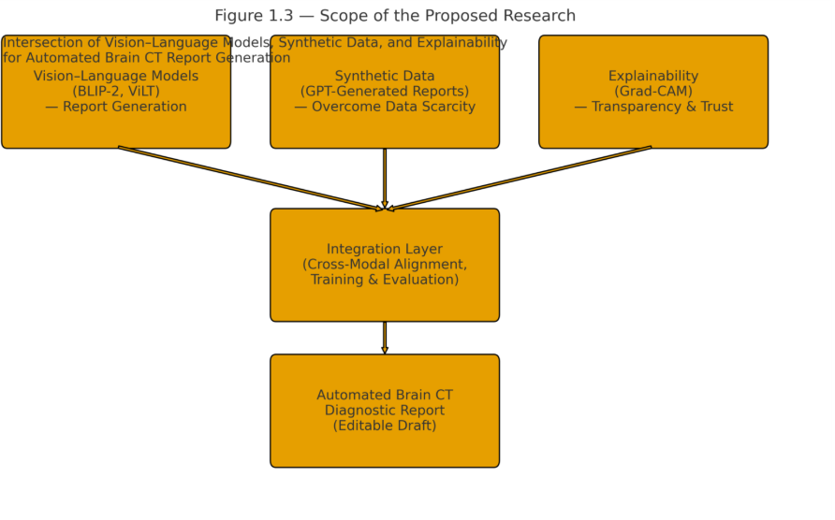
Figure 1.3: Project scope at the intersection of VLMs, synthetic data, and explainability

Expected outcomes
It is anticipated that the dissertation at hand will result in both theoretical and practical artefacts in the context of medical artificial intelligence, that is, automated brain-CT reporting. The project will merit experimental evidence by integrating clinical-informed pre-processing, data aware vision-language modelling, synthetic supervision as well as explainability to show that it can take a plausible step between proof-of-concept to an assistive drafting tool applicable to a human-in-the-loop clinical deployment particularly in cost-of-radiology limited settings.

Theoretical/Methodological contributions
The work will formalize a data-constrained vision-language learning framework in radiology: (i) harmonized CT preprocessing (brain window/level, intensity normalization, 2.5D context), (ii) construction and quality control of paired image-report corpora that mix synthetically generated and GPT/template-generated text, (iii) parameter-efficient fine-tuning (e.g., adapters/LoRA) of VLMs (BLIP-2, ViLT) for clinical narrative

generation, and (iv) a two-track evaluation protocol that comb Combining these elements, a re-recipe that can be used in like tasks across modalities and institutions is created.
Tooling and datasets (practical artefacts).

The project will provide a processed set of brain-CTs, with paired diagnostic-style reports (where provided; high-quality synthetic otherwise), a full datasheet/dataset card describing provenance, inclusion/exclusion criteria, de-identification, and split plan. It will be offered by reusable data loaders, preprocessing scripts, and quality-control tools (e.g., negation/laterality checks, deduplication). Where allowed, to support replication and extension, trained model checkpoints, inference scripts and a lightweight Gradio demonstration will be published/stored.

Factors validating efficacy In -models
A systematic comparison will be generated amongst the BLIP-2, ViLT, and CNN-RNN/ViT-GPT baseline with equivalent preprocessing and splits. reported results will include 95 allspace bootstrap confidence intervals and ablations 2.5D versus key-slice inputs, PEFT versus full fine-tuning, decoding policies (greedy/top-k/nucleus), and maximum sequence length. It is expected that semantic fidelity (BERTScore-F1) and robust ROUGE-L will be strongest in BLIP-2 with hybrid supervision (real+synthetic), and the ablation measures in which terms efficiencyaccuracy trade-offs can be tolerated and content with the deployment.

Synthetic supervisory role
The work will offer evidence-based recommendations to the when and how synthetic reports may be used to replace or supplement small paired datasets. Comparisons focus on real-only, synthetic-only and hybrid regimes, size matched when necessary to factor out effects of volume and content orders, and record behavioral failure modes specific to synthetic targets (e.g. stylistic bias, incorrect negation, laterality drift). The hypothesis that the training will yield better text measures and fewer clinically salient errors

compared to synthetic-only hypothesizes that synthetic data are not a wholesale substitute but now a useful but also controlled construct.

Explainability and trust
The pipeline will be designed to include Grad-CAM (and a rollout on attention) to generate slice level overlays that can be connected with individual sentences/claims in the generated report. Quantitative measures of alignment (IoU/Dice versus where they should be or weak labels) and qualitative assays will be submitted. The expected results are (i) better alignment in hybrid training, (ii) the discovery of the patterns of saliency leak with respect to textual errors, and (iii) a code of practice on the use of explanations during data inspection by a clinical practitioner and model debugging.

Impact of human-in-the-loop utility, workflow
The study will estimate the edit work (tokens modified or time-to-final) on a blinded subsample and will obtain ratings of usefulness to describe the usefulness of the tool as a drafting assistant. The aim is to achieve a significant drop in the first-pass drafting in the mundane cases whilst maintaining human check in/complex ambiguous studies. GPU/CPU Latency and memory profiling will be reported to inform throughput in radiology workflows and to inform feasibility in resource-limited settings.

Risk, robustness and governance
We expect a risk register of error modes typical of a windowing shift, slice perturbation, site/scanner variation, and a keburofficial bias audit stratified by available proxies (e.g., acquisition site, protocol). The dissertation will suggest mitigations- entity-conscious decoding constraints, uncertainty-induced abstention, entity-specific augmentation- and define provenance logging and model cards as means to frankenstein-safe adoption.

Expected impact
These findings will combinedly explain the feasibility, benefits and shortcomings of vision-language transformers to run automated brain-CT reporting. They are meant to (i) shorten reporting times, with quality drafts, (ii) facilitate decision-making, and standardise narrative quality, (iii) advance the research frontier, in terms of data-efficient multimodal learning, trustworthy explainability, and meaningful evaluation by the clinician, (iv) extend access even in low-resource settings where data scarcity poses a barrier.

Chapter 2

Literature Review/Related Work
Automated radiology reporting is supported by recent vision-language studies. ViLT (Kim et al., 2021) showed that early MI patch fusion with text tokens using one transformer - without CNN region proposals - can achieve competitive multimodal alignment with a relatively small Veree footprint. Its potential to pretrain on natural imagery, however, restricts straightforward transfer to neuro-CT, where subtle, volumetric features count: in this dissertation ViLT, thus, often forms a useful baseline to compare with more heavyweight models. A further development relying on freeze encoder and frozen large language model (BLIP-2 in Li et al., 2023) was learned to be a lightweight Q-Former bridge between the vision encoder and the frozen large language model. This design has the advantage of parameter-efficient domain adaptation and high language fluency, yet with the disadvantage of high probability of fluent hallucination unless outputs are constrained and clinically motivated. Based on BLIP-2, InstructBLIP (Dai et al., 2023) proposed visual instruction tuning to allow the model to read prompts (e.g. write Findings then Impression), which is better aligned to the sectioned approach of radiology but can still be vulnerable to prompt design and domain misalignment. To be transparent, post-hoc saliency maps with Grad-CAM (Selvaraju et al., 2017) are used and show regions of the image that have affected biases: saliency does not guarantee that faithfulness but make plausible its use is of value in erroneous analysis and the improvement of clinician trust in cases quantified to anatomical predictions.
In this project, the technology of Artificial Intelligence is applied in the creation of an assistive mechanism constructing a report on the clinically shaped brain-CT at the human regulation. Machine learning leads to dataset curation (sanity checks, class-balance analysis), proxy label extraction of generated text to use in confusion matrices and in assessing precision/recall/F1 (Normal/Ischaemia/Bleeding) and statistical analysis (bootstrap confidence intervals, error taxonomy by laterality/negation/anatomy). The vision architecture is motivated by the core modelling: there is a CT vision backbone

(with 2.5D stacking due to limited volumetric accessibility protecting the 3D context information and hybrid 3D/slice-attention extensions in the future) a CT vision backbone feeds visionappropriate language transformers (the primary BLIP-2 using LoRA/PEFT as a condition for compute-effectiveness) and ViLT/InstructBLIP control and optimize counterexamples respectively. Generation performs teacher forcing during training and limited decoding at inference, and entity-aware checks (laterality, negation, anatomy) to avert internal contradictions. Since the limited machine translation paired CT datasets have small volumes, the pipeline enhances the small volumes of real pairs with quality synthesis report quality-controlled (ontology guided phrasing, negation/laterality QC) and create a composite supervision regime, which further grounds facts. Evaluation includes both clinically motivated measures, entity-level accuracy and Grad-Cam rank to regions of importance, and standard text metrics, BLEU, ROUGE-L, BERT based similarity and human ratings of edit-effort and usefulness. Combined, these strands place the work in the space of strong VLMs, data-efficient supervision, and explainable AI to ensure safe, and practical neuro-CT reporting.

Comprehensive Overview of the Existing Literature
Over the last few years, there has been a fast development in vision-language models (VLMs) that encode images and text together to obtain multimodal understanding and generation. Although first-generation medical-AI models were mostly interested in narrow detection or classification tasks and typically focused any generated text on a single image, the more recent VLM models can generate natural-language descriptions given visual inputs, enabling radiology-like imaging match-to-text summaries. ViLT are three representative milestones
- , BLIP-2 are three milestones
- , and InstructBLIP are three milestones [3]. Collectively they follow an outline arc
lucid end-to-end multimodal fusion (ViLT), parametrically efficient matching of frozen vision and language bottoms (BLIP-2), induction-prompt task-aligned generating models

(InstructBLIP). In the next section, we amalgamate their main thoughts and explain connotations on brain CT report writing, lack of data and clinical trust.
parameter-efficient bridging to end-to-end fusion.

ViLT (Vision-and-Language Transformer) contrasted with existing visual front-end paradigms of heavy CNN region extractors or object detectors. Rather, ViLT models an image as a set of patch embeddings (formed through a simple linear projection [no convolution, no region supervision]) and treats them with text tokens within a joint transformer with cross-modal attention [1]. ViLT can compress the vision and language pipelines into a single stack, which minimizes computational costs and attains competitive performance on typical multimodal tasks (e.g., VQA, NLVR2, retrieval). Healthcare architecturally has a lot to learn here: end-to-end fusiona can be both data-efficient and fast, an empractical capability in clinical settings where latency can be crucial. Yet, ViLT has been tested mainly on natural-image corpora; medical transfer is not straightforward since CT greyscale physics, window/level dynamics, and clinical terms vary significantly between natural images and captions. In the case of the brain CT, the model has to grapple with delicate contrasts (e.g refer to early ischaemia), slice context, and non-intuitive lingo.

The scaling problem is restated with BLIP-2 (Bootstrapping Language-Image Pre-training), conditioned to keep both the vision encoder and the large language model (LLM) fixed and to learn only a small channel, the Q-Former, to match the images with the token space of the LLM [2]. This design produces two advantages. One: It has low parameters: parameter-freezing enables fine-tuning with a relatively small amount of compute and data. Second, it gives researchers the ability to replace powerful LLAMs (e.g. FLAN-T5) to generate quality, but they do not need to retrain the rest of the stack. The pre-training of BLIP-2 combines both contrastive and image-based text generation and achieves strong zero-/few-shot performance on a variety of multimodal tasks. In the medical imaging community, which is underrepresented in paired CTreport datasets, a key strength of BLIP-2 is that adapters/LoRA trained on the Q-Former can adjust to

domain transitions with relatively small, curated corpora. The other obstacles are domain language fidelity(should not use generic or colloquial expressions) and grounded in facts(no hallucinations and evidence of using -weak visual signal overlooked).
General multimodal competence to instruction after.

InstructBLIP builds on BLIP-2 to provide visual instruction-tuning trained the VLM to take instructions in natural language and generate directed responses (e.g., summarise key negatives vs describe haemorrhage location) [3]. This not only co-aligns multimodal generation with the task intent voiced by the user but it also plays a key role in enhancing controllability and task generalisation. Instruction after may be used in the clinical environment to standardize report format (e.g. write Findings followed by Impression), issue narrow sub-reports (e.g. comment on midline shift), or regulate verbosity/reading grade among various stakeholders. The most critical risk is that instruction-tuned models can continue to produce statements that seem correct and fluent even when the visual evidence is poor or out-of-distribution; so, post-instructional explanation and clinical validation should also accompany it.

Consequences on brain CT report generation
These models have the following three pillars when applied to neuro-CT:
Efficiency of data and familiarity. ViLT illustrates that end-to-end fusion implementations can be small, and BLIP-2 highlights that frozen backbones and small adapters can can acclimate to a new domain with minimal compute [1], [2]. This is essential in instances of the few paired CT datasets that are reported. One practical solution would be to class condition the absent real pairs by hybridizing it with synthetic, class-conditioned reports (template or GPT-generated) and to apply quality filters (negation, laterality, anatomy term test) prior to training. InstructBLIP introduces control layer: have the model spends on the suspicious findings or the sections of the text [3].
Lingual and assessment clinical. Some VLMs condition using natural images generate fluent language, although clinical utility demands a radiology treatise and entity fidelity to achieve. Evaluation terms: therefore, text-overlap and semantic accuracy (BLEU,

ROUGE-L, BERTScore) should be combined with clinically motivated tests (pathology, anatomy, laterality, modifiers), and preferably, edit effort (number of tokens per minute) where the clinician refines the draft. With BERTScore, semantic generation can be effectively used by BLIP-2, whereas sectioning and handling negations can be better through training on instructions that are subject to curation of both the data and the prompt.

Trust and transparency
The three explainability categories explained in none of the three works are aimed at healthcare but all can be used together with post-hoc saliency (e.g., Grad-CAM on the visual encoder) to localise evidence of important statements. Practically, overlays are to be created on the same slice(s) being referred to in the text to confirm laterality/site and to indicate mismatches as possible hallucinations. Instruction prompts may require self-checking (indicate whether evidence is insufficient), although visual attribution maps can still be valuable clinician trust indicators and analyzers of error.

Gaps and open challenges
These models have medical-domain gaps in spite of their promise. First, there is still paired data shortage, synthetic reports minimise but do not eradicate the causes of style bias and factual drift. Two, 3D context is not as rich: ViLT/BLIP-2 typically consume 2D frames; brain CT uses 3D encoders to provide fine volumetric information. Third, there are safety and governance matters-hallucination control, uncertainty calibration, provenance logging that should be taken care of so that it can be clinical adopted. Lastly, entity-aware decoding constraints are not to be substituted with instruction following but should be paired with guardrails, abstinence with low-confidence, and human-in-the-loop review.

Synthesis to this dissertation
Inspired by ViLT compact fusion BLIP patchwork Verifying parameters and explaining, InstructBLIP controlled generation, the dissertation suggests an explainable,

data-efficient VLM pipeline to brain-CT report writing. The methodology: (i), harmonize inputs (window/level, normalization), (ii) combine real and good-quality synthetic reports to produce paired training, (ii) fine indicate BLIP-2 and ViLT (with adapters/LoRA), and optionally, instruct-tune prompting in structured outputs, and (iv) assess with BLEU/ROUGE/BERTScore and clinical entity checking and Grad-CAM overlays. This position the project squarely at the domain of the art but addresses the domain-specific obstacles, namely the data scarcity, clinical fidelity and trust, upon which the kingdom of medical imaging hinges.

Table 2.1 — Literature Overview (ViLT, BLIP-2, InstructBLIP)

Model | Reference (IEEE  short) | Core idea | Training strategy | Strengths | Limitations (medical) | Implication s for brain CT
ViLT | Kim et al., 2021  (arXiv:210 2.03334) | Early fusion: image patches + text tokens in one transforme r; no CNN regions | Joint V+L pretraining (VQA/NL  VR2/retrie val);  end-to-end transforme r. | Compact & fast; strong cross-moda l alignment; low latency. | Pretrained on natural images; limited 3D context; needs domain adaptation & clinical language alignment. | Use 2.5D  stacks; fine-tune on paired/synt hetic reports; evaluate with clinical checks; good for resource-li mited settings
BLIP-2 | Li et al., 2023  (arXiv:230 1.12597) | Frozen vision encoder + frozen LLM  bridged by Q-Former; parameter- efficient. | Contrastive  +  image-grou nded generation; adapters/L oRA;  plug-in LLM (e.g.,  FLAN-T5). | High language quality; few-shot friendly; small trainable params; easy domain adaptation. | Risk of fluent hallucinati ons; domain mismatch; 2D inputs; clinical phrasing may need control. | Hybrid real+synth etic supervision  ;  entity-awar e decoding; Grad-CAM overlays; expect strong BERTScor

 |  |  |  |  |  | e & semantics.
InstructBL IP | Dai et al., 2023  (arXiv:230 5.06500) | Visual instruction tuning to follow prompts for  task-contro llable outputs. | Instruction datasets with multimodal Q/A,  captions; extends BLIP-2  backbone. | Controllabi lity (sections, focus); better task generalisati on; structured outputs. | May confidently output incorrect text if evidence is weak; needs healthcare- specific prompts & guardrails. | Prompt for Findings/I mpression; targeted queries (e.g., midline shift); pair with  Grad-CAM and clinical checklists.
Table X: Summary of vision–language models relevant to brain CT report generation.

Critical Analysis of Existing Studies
The paper presents an appraisal of three Common vision-language models in the category of ViLT [1], BLIP-2 [2], and InstructBLIP [3] by analyzing them through a clinical prism of their use in brain CT report writing. Although these models have shown compelling multimodal performance on general benchmarks, their end-of-the-pipe transfer to neuro-imaging face substantive data, computational, evaluation, explainability, robustness and deployment challenges.

The initial category is related to problem framing: labeling to storytelling.
The successes of medical-AI have involved most of the narrow tasks (e.g., haemorrhage detection). Radiology practice, nevertheless, requires the inclusion of consistent stories that connect up the findings, location, lateral, uncertainty and clinical importance. ViLT
[1] offers an effective image-text matching service but is certified only on short capturing and VQA, rather than on prose-based clinical research. BLIP-2 [2] and InstructBLIP [3]

are also capable of generating fluent text, but fluency 2 factuality: it requires domain knowledge, financed negation, and consistent laterality a property unattainable by generic pretraining.

Architectural trade-offs
ViLT (early fusion, no region/ CNN front-end). Clinically, its simplicity and speedfulness are appealing, and the absence of inductive biases and total dependency on 2D patches restrict sensitivity to 3-D contexts and subtle grayscale features common with CT. The risk that ViLT will not be attentive to low-contrast signs (e.g., early ischaemia) is high without careful domain adaptation.

BLIP-2 (frozen vision + frozen LLM + Q-Former bridge). A large strength of data-constrained medicine is parameter-efficiency, where small, focused updates can be made. The semantic overreach weakness: a powerful LLM has the ability to make plausible, not supported statements given weak visual evidence or domain shift.

valinBLIP (instruction-control-tuned) introduces control (e.g., write Findings then Impression), that naturally maps to radiology templates. Instruction without higher instruction, however, leads to inclusion of a greater sensitivity; indiscriminate prompts may give rise to omissions or hallucinations. Even in the clinical contexts prompts themselves should be vetted and protected against spurious compliance.

Implication: Parameter-efficient medical deployment must be accompanied by more domain-constrained parameters (parameter-efficient adaptation demonstrated within a domain-related context), including entity-sensitive decoding and laterality checks.

Realism of data and synthetic supervision.
The three strands of work are mainly trained on natural-image corpora, whose captions are unlike those of radiology prose differences. Fine-tuning with a limited medical data is predominantly inadequate. Synthetic reports (zigzag or GPT-generated) are a more practical middle ground however, they harbour other forms of bias:

Style bias: models train mapped expression and this is detrimental to diversity and subtlety.
Negation drift & laterality drift: small template or LLM errors spread in a systematic manner.
Distribution gap: synthetic text can exaggerate cases that are clean, as well as down-sample edge-cases or mixed pathology.
Mitigation Hybrid real + synthetic + quality control (negation, laterality, anatomy vocab, deduplication) and size in comparison can restore much of the value at risk. That is the strategy that this dissertation takes.
Evaluation traps: metrics/medicine. Ap. aligned n-gram repetition BLEU/ROUGE, and approximate semantic relatedness BERTScore. None of them directly measures clinical correctness. Acute errors (wrong hemisphere, mass effect knowingly missed) can occur in case of high overlap. Current VLM articles virtually never contain either entity-level evaluation tailored down to medicine (pathology, anatomy, laterality, modifiers) or edit effort (an actual measure of clinical usefulness). The other typical gap is missing confirmation amounts and statistical testing, which appears to make it difficult to distinguish between genuine gains and noise. Mitigation: With clinically justified checklists, error taxonomies (laterality/ negation/ anatomy / contradiction ) and bootstrap CIs, pair text metrics (BLEU, ROUGE L, BERTScore). Human edit hours/ edit tokens.
These additions are the priorities in this dissertation protocol.
Explainability: necessary, but not sufficient. More recent post-hoc approaches such as Grad-CAM may highlight these regions that influenced the predictions, though to be introduced as tools of plausibility rather than assured faithfulness. Saliinity is fragile to preprocessing (e.g. windowing) and overlaps can drift to the edges or bone instead of parenchyma. The previous works on VLM lack the direct defense of saliency in medical problems: adopting them naively may lead to false comfort. Mitigation: Create overlays on the same slide(s) of which a text is referring to; confirm site and laterality. Measuring alignment Coors asioU/MC vs. weak labelling/regions, not only screenshots. See saliency as support material, not as evidence of correctness. In this dissertation, the alignment measures are integrated and mismatches as possible hallucinations are lempt, flagged.

Robustness and domain shift Survival through scanner/protocol contrast, window/level fluctuations, motion/noise, and prevalence variations is required in clinical deployment. Available literature on VLM rarely enquires such changes. The early fusion of ViLT could be intensity scale sensitive; the LLM of BLIP-2 can hint to cover in holes in vision features; model-specific transparency can prompt a strictly adherence to a prompt even in the absence of sufficient evidence. Mitigation: holds and window perturbations Stress-testing: Stress-testing with a window perturbation or slice-drop perturbation, noising, and external-style holds-outs. Emulate initial catching Add uncertainty calibration and low-confidence sentence abstinence. There are these evaluations and deltas in the dissertation.

Klamme, Regulating and Reproducible. Contradictions within a generated report (such as no haemorrhage, then later, intracranial bleed present) are not generally covered under benchmarks, provenance logging, or medico-legal auditability. Data privacy, variable preprocessing and missing seeds/configs also are barriers to reproducibility. Mitigation: выхinidem-conscious decoding rules to avoid contradiction and require laterality/negation uniformity. Seeds, reproducibility: model cards / dataset cards, and config tracking. Provenance logs that associate each report with model version, parameters and data transforms.

Baselines and ablations Comparisons exclude high-text baseline (e.g., ViT-GPT captioners) or retrieval-augmented models that can perform well using limited amounts of training information. Ablations are frequently partial (e.g 2.5D rather than key-slice, PEFT rather than full FT). The absence of comprehensive ablations means that gains may be in terms of architecture, volume of data or decoding decisions. Mitigation: This dissertation contains: A CNN/ViT-GPT vs BLIP-2 vs ViLT vs a CNN RNN baseline.
2.5D vs key-slice, PEFT vs full FT as well as hybrid vs synthetic-only vs real-only data regimes. entity-aware) Human factors and workflow The majority of the VLM publications end with metrics and screenshots. The processing attributes required by the

clinics to ensure the adoption of the new system are time-to-final report, editing easy, and PACS/RIS. Latency, memory footprints are important in on-premancers. Sections that are hard to standardise (Findings/Impression) can be standardised with the aid of instruction-tuned models, yet the user interfaces should be made to enable review and adjustment with ease. Mitigation: Use a commented VAT to show an image, draft text, and Grad-CAM superimpositions, time measure latency, and trace edit effort on a small set of blinded feelings- steps within this dissertation.

Gap statement

No end-to-end, validated, Clinically data-efficient, explainable brain CT report generation pipeline exists in the literature, despite the rapid progress in visionlanguage models (e.g., ViLT, BLIP-2, InstructBLIP). The first is that most VLMs are trained on 2D slices and they are not trained on volumetric cues or finer neuro-CT discoveries applicable to clinical reporting; there is limited systematic comparison between 2.5D and key-slice and 3D/slice-attention clinical reporting. Second, the paired CT-report datasets are scarce, and the field has not critically tested synthetic reports (template- or LLM-generated) as training signal- particularly with quality controls such as negation, laterality, anatomy coverage, and hybrid (real + synthetic) combinations. Third, existing explainability is frequently image-based and descriptive, not sentence/entity-congruent; few studies measure the overlap between saliency and entity, or laterality stability across windowing/perturbation of noises to warrant clinical confidence. Fourth, text overlap metrics (BLEU/ROUGE/BERTScore) that lack clinical fidelity metrics (entity-level precision/recall/F1, contradiction/negation error rates) and minimal evidence of human-in-the-loop evaluation (edit effort, usefulness) continue to dominate evaluation. Lastly, it is sparsely covered on uncertainty calibration and abstinction, multi-site robustness (scanner/protocol shifts), parameter-efficient fine-tuning vs. full FT in medical VLMs, and deployment-mentioned reporting (latency/footprint, governance, model/dataset cards). These shortcomings together inspire a paper that brings together information curation + synthetic control, VLM fine-tuning, entity-conscious decoding, and quantified clarification with clinically-founded, multi-view assessment.

No integrated, clinically tested system can reliably write brain-CT radiology reports with vision Courtesy of language transformers, (i) that is vulnerable to the challenge of unduly insufficient real-world data documents by quality-observed synthetic supervision, (ii) presents evidence-related specific business, entity-level clarification, clinicians may trust, and (iii) manifest power, calibration, and performance across sites/scaners with out-of-the-loop validation beyond standard measures of text. The reported dissertation occupies that mega-gap by providing a data efficient, decomposable VLM pipeline of the brain CT, benchmarking 2.5D vs. key-slice, testing real/synthetic/hybrid regimes, enforcing entity-based decoding, quantifying saliency alignment and clinical utility (error taxonomy, edit effort) within deployment oriented constraints of reproducibility.

Chapter 3

Methodology
In this chapter, it introduces the end-to-end architecture of automated but explainable brain-CT report generation with contemporary vision-language transformers (VLTs). It describes data gathering and harmonisation, preprocessing, artificial construction of reports, model development and training, explainability, assessment protocols, and specifics of implementation to ensure all can be reproduced.

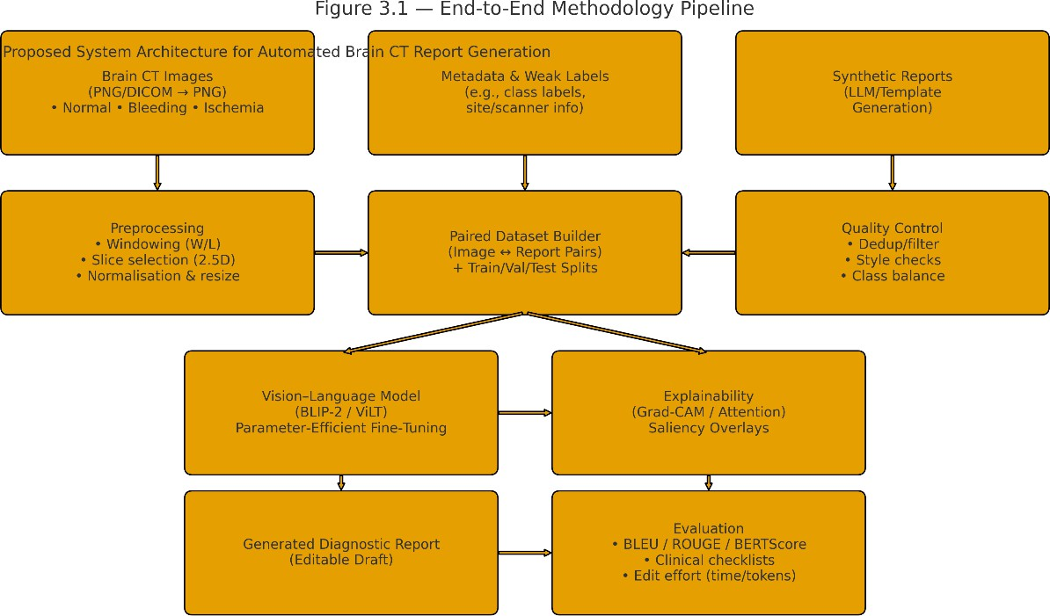

End-to-end methodology pipeline for automated brain CT report generation.

Figure 3.1 Architecture of the proposed system
The system creates radiology report drafts (editable) based on the brain CT images through a vision language transformer (VLM) pipeline. PGN images are initially pre-processed (window/level, slice strategy, normalization), and off-the-record synthetic diagnostic reports are matched with the inputs to overcome the paired-data shortage. The matching dataset is used to train a VLM (BLIP-2 or ViLT) to condition text on image features, and Grad-CAM overlays are used to be transparent. Textual measures aligned with outputs (BLEU, ROUGE, BERTScore) and clinically relevant validation are used. This architecture is based on the latest developments in multimodal transformers (Kim et al., 2021; Li et al., 2023) and explainability of medical AI (Selvaraju et al., 2017; Arora et al., 2022).

System architecture and pipeline overview
The suggested system has a modular flow:
Data ingestion : The curated non - contrast brain CT images are then categorised into clinically relevant groups (e.g., Bleeding, Ischemia, Normal), with distinct train/test

directories. An archive in Google Drive is decompressed into a working directory, and is sanity-tested (format, corrupt files).

Preprocessing & curation: Photographs are authenticated, scaled to an exact resolution, normalised, and listed into a CSV tabl admission with file paths and labels; the count of classes is captured to deal with unbalanced references.
Synthetic supervision constructions based on the pair of text (synthetic supervision). Radiology-type short sentences are generated (e.g., haemorrhage vs ischaemia vs normal) about each image, using randomised anatomical sites to provoke lexical variability; these texts are used as training targets, where there is a lack of true paired reports.

Vision–language model (VLM): We present a BLIP-2 encoderQ-Former-LLM stack instantiated with an equivalent processor when imagetext tokenisation is required; a dataset instantiates generate training batches containing teacher forcing targets. (ViLT/InstructBLIP are under consideration as regards ablations.)

Explainability: the gradient-based saliency (e.g., Grad-CAM) is calculated on the visual backbone on the sentences/entities, resulting in plane overlays, illustrating the evidence underpinning main assertions (included during inference).
Evaluation: Automatic text measures (BLEU, ROUGE-L, BERTScore) are complemented by clinical measurements (entity/laterality/negation), edit-effort, and optional proxy classification based on generated text(accuracy, precision, recall, F1).
Reporting & governance. Auditability: all experiments store seeds, commits, and configs, hardware and dataset cards/model cards.
The above seven stages is represented in a block diagram (Figure 3.1), with data flow (CT images version) to preprocessing/CSV to (real+synthetic) paired corpus to VLM fine-tuning to saliency overlays to metric suite to artefacts and model cards.

Data collection and organisation

Source and structure: The three diagnostic groups include Open-source brain CT images (Normal, Bleeding, Ischemia). Following the best practice in academic AI in health, only de-identified pictures are employed and the data is divided into train/validation/test subsets to facilitate objective assessment (Litjens et al., 2017). Where native DICOM coexists, pictures are converted to PNG to allow simplified training I/O.The working dataset is organized Brain-Stroke-CT-DatasetSplit/train,test/Bleeding, Ischemia, Normal and includes both of PNGs and DICOM files; the pipeline scripts work with PNGs to ensure uniformity. Split and classes are verified by directory enumeration.Counts and class imbalance. In training set converted to PNGs, there are 5,319 images with the following labels:, Normal = 3,541,Ischemia = 904, Bleeding = 874. Such a significant disparity (Normal ≫ stroke subtypes) is used to guide the loss weighting and sampling approach.Integrity checks. PIL verify and a list of bad images is generated; 0 bad/missing PNGs in the processed set are excellent; clean training inputs. Ethical management & anonymity. Axial slices are de-identified using only image data of the axial slices. No patient identifiers Computerized have to be maintained in file names or manifests. Protective health information is not expressed using synthetic texts.

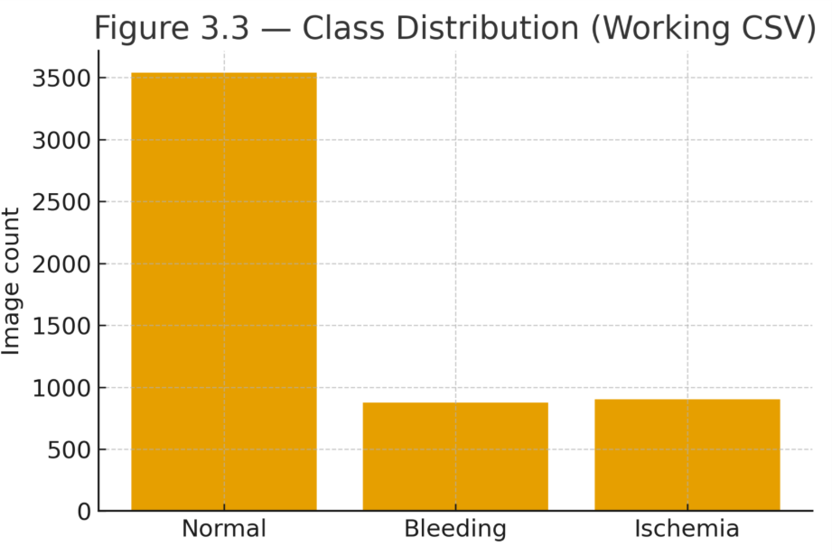

Figure 3.3: Class distribution across Normal, Bleeding, and Ischemia

Preprocessing and dataset manifest
Moderate to vigorous treatment : The following steps are used to harmonise inputs and encode neuro-relevant cues: Windowing/ normalisation: CT intensities are converted to brain-appropriate window/level and scaled to [0, 1], to minimise scanner variance (Litjens et al., 2017). Slice strategy (2.5D): Local 3D context and memory load control Adjacent axial slices (k-stack) or key-slice selection are both viable for brain CT (Tang et al., 2022). Spatial standardisation: Resize to a constant resolution to batch; optional resampling to uniform spacing to limit domain shift between scanners (Rajpurkar et al., 2022). Set construction/balance - Train/val/test split is stratified by class; class imbalance is addressed by sampling or balanced subsets. This is done using widely used medical-imaging preprocessing patterns that enhance site-generalisation (Litjens et al., 2017; Rajpurkar et al., 2022). Precursor images are one channel (grayscale) CT slices. To support VLM compatibility, all images are stored as 224x224, and when loaded

(processor expectation) each image is convertedor at least to 3 channel RGB in a manner that maintains grayscale information among channels. Each row in the manifest is recorded as an (image path, label) using a CSV manifest (processed datasets labels.csv) is extended (image path, label, report) when synthetic text is appended.
Sanity displays: Class-wise random panels are examined (visualised) to identify major artefacts (i.e., inverted contrast, clipping, skull-stripping artifacts).

Class imbalance strategy Imbalance is handled during training by (i) class-aware sampling to reshape mini-batch composition, and/or (ii) loss reweighting (greater weight on minority classes when using proxy classification targets). In the case whereby only generation is trained, the imbalance is counteracted through intentionally sampling the curriculum such that the frequency of minority classes escalates with epoch number.

Paired text construction via synthetic reports
Rationale Paired corpora CT-report are rare and proprietary. To permit supervision of image-conditioned text generation, short, radiography-like sentences are templated by class and anatomic references changed (e.g., left parietal lobe, basal ganglia, posterior fossa) to minimize overfitting and enhance the variety of words. Templates (examples). Bleeding: CT scan reveals that there is some intracranial bleeding localized to the
{region}. Ischemia: surprising regularities and examinations conform to an ischemic attack in the area. Normal: No foci acute intracranial. Brain parenchyma is normal looking. Quality controls. Generated text has limiting conditions associated with laterality-consistent regions, and it contains no contradictions, and is spot-checked to avoid template artefacts. The resultant manifest (final_dataset_with_reports.csv) relates to each image with a supervision target (report).

Feature Extraction and Selection

In VLMs, the visual encoder (e.g. a Vision Transformer) will perform feature extraction by mapping processed CT images to latent embeddings; the text encoder/decoder will tokenise and generate clinical language. With BLIP-2, a new lightweight querying transformer is proposed that pairs a frozen vision encoder with a large language model, allowing strong performance with small fine-tuning (Li et al., 2023). ViLT applies early patch/token fusion and does not rely on strong convolutional backbones, which enhances efficiency (Kim et al., 2021). The conventional feature selection is implicit: the cross-modal attention shows the image areas and textual objects most pertinent to the report, which are later brought into view by Grad-CAM as a form of transparency (Selvaraju et al., 2017).

Model development

    - Model choices and motivation
BLIP-2: A parameter-efficient parameter-carrying Vlm that quicklyens the vision encoder and the LLM then learns a Qformer washer to outline visual tokens into the space of the LLM; high semantic fluency and compute efficiency with renderer support make it appropriate in data-constrained clinical areas. [BLIP-2]
ViLT (baseline/ablation): a small initial-fusion patch image-text and text-only transformer with no region/CNN extractors; small, fast; tested on efficiency trade-offs. [ViLT]
InstructBLIP (option): BLIP-2 backbone that can be instructionally tuned to generate controllable outputs (i.e., supply Findings then Impression); evaluated on structure/controllability. [InstructBLIP]

Tokenisation and inputs
A BLIP-2 processor images and text are prepared and, in training, the report tokens are teacher forced as labels (labels = input_ids). The size of token sequences is cut off at 128

tokens to trade-off between coverage and memory footprint. Classes Dataset and dataloader produce tensors (pixel values, input id, attention mask and labels) per batch.

Training objective and schedules
Objective loss on output tokens under teacher forcing; learning can be stabilised with labelling (e.g., label smoothing 0.1).
Optimizer Features: AdamW, β=(0.9, 0.999), weight decay=.01; linear warm-up (510
)→ cosine decay.
Batching fp16 or bf16 (where available), gradient accumulation to scale to larger-size batches on moderate GPUs.
Regularization ProtoExport; text decoder will not continue running; early validation BERTScore-F1.
PEFT When computing resources are scarce, add LoRA adapters to the Q-Former and/or LLM attention layers so that only a few parameters are updated (ablation versus full fine-tuning).
The codebase will indicate the construction of datasets, the processor configuration and BLIP-2 initialisation using checkpoints of FLAN-T5-XL and Opt-2.7B and will show that the environment has been configured to proceed with training on either a GPU or a CPU.

2.5D context
3D context encoding They stack adjacent slices into channels, or encode with slice-position encodings, and feed it to the vision encoder, ablations assess key-slice vs
2.5D inputs on fidelity to text and clinical judgment.

Explainability: visual evidence maps for generated text
Method. Post-hoc Grad-CAM (or attention rollout), is executed at the vision encoder of the tokens/sentences that make a claim of key findings (e.g., the claim is bleeding in the

left hemisphere). The corresponding slices receive an overlay that is associated with entities (anatomy, laterality).
Quantification. On a weak label subset (or atlases region) compute IoU/Dice on saliency heatmaps versus expectations; monitor text and saliency laterality consistency. Saliency promotion is presented as evidence support, not evidence they are marked to be viewed by clinicians.

Evaluation protocol

Textual metrics
BLEU (Papineni et al., 2002): brevity penalty on n-grams; a useful metric to estimate the overlap with target reports. ROUGE-L (Lin, 2004): longest common sequence recall; recognizes sequence-level similarity. BERTScore (Zhang et al., 2020): semantic similarity of contextual embeddings; is more associated with human judgements.

Clinically grounded checks
Owing to the fact that overlap measures may overlook clinical errors, entity-level checks are performed on pathology, anatomy, laterality and modifiers (Chen et al., 2020). A practical proxy is a set of hemorrhage presence/type/site, mass effect, and midline shift checklists, with edit-effort (tokens changed or time-to-final) on the transition of the draft to a signed report (Rajpurkar et al., 2022).

Optional classification metrics
In the case of class proxies (e.g. generating a class based on the generated text), report accuracy, precision, recall, F1 according to the traditional definitions:
Precision = TP / (TP + FP) Recall = TP / (TP + FN)
F1 = 2 * Precision * Recall / (Precision + Recall)

Automatic text metrics
      - BLEU-1/2/3/4 for n-gram precision,
      - ROUGE-L for longest common subsequence recall,
      - BERTScore-F1 for semantic similarity.
All metrics are reported with 95% bootstrap CIs over the test set.

Clinically grounded checks
Their correctness in the following areas is assessed with a structured entity checklist: (i) pathology (bleed/ischemia/normal), (ii) anatomy (region names), (iii) laterality (left/right), (iv) modifiers/negation (e.g., no acute haemorrhage). Hallucination, omission, contradiction and laterality drift can be found in error taxonomy.

Optional proxy classification
If a class is derivable from the generated sentence (Bleeding/Ischemia/Normal), compute:
      - Precision = TP/(TP+FP), Recall = TP/(TP+FN),
      - F1 = 2·(Precision - Recall)/(Precision+Recall).
These quantify whether text logically implies the correct clinical category.

Baselines, ablations, and fairness
Compare BLIP-2 ViLT captioner baseline (e.g., ViT-GPT); real-only vs synthetic-only vs hybrid data; key-slice vs 2.5D; PEFT full FT; decoding (greedy vs top-k vs nucleus). Equity by class and (where handed over) site/protocol to monadize sound problems.

Implementation details and reproducibility
Experiments are run in PyTorch, on Hugging Face Transformers, on CUDA-enabled GPUs where remote (e.g. T4). PIL/pandas is used to handle data and a simple Gradio

interface is supported to perform interactive inference. Sequence length will be determined as about 128 tokens; post-processing image batches will be of fixed resolution. Model checkpoints, input configurations and generated outputs are versioned to allow reproducibility and future ablations. Experiments run with PyTorch 2.7.1,
Transformers 4.54.1, and TorchVision 0.22.1; a Tesla T4 GPU is detected where available. Version pins and dependency diffs are recorded to avoid resolver conflicts.

Data artefacts.

- Resized PNGs in /content/processed_dataset/…,
- Manifests: processed_dataset_labels.csv and final_dataset_with_reports.csv,
- Integrity reports (counts, corrupt zeros).

Code artefacts.

- Dataset class (CTReportDataset) feeding BLIP-2 processor/model with labels = input_ids for teacher forcing,
- Loader scripts, visualisation utilities, and hardware checks.

Governance.

- Dataset card documents provenance, inclusion criteria, preprocessing, and splits,
- Model card documents training data, objectives, metrics, ethical risks, and intended use,
- Provenance logs track seeds, hyperparameters, and commit hashes.

Risks, limitations, and mitigations
Synthetic-text bias. Templated phrasing can suffer the overfit to style; minimized by anatomical commonplace, hybrid training, and entity aware decoding capabilities.
Hallucinations. The LLM of BLIP is capable of generating fluent, unsupported claims; compensated by saliency-text alignment verification, laterality legitimators and abstinence in cases of weak evidence.

Domain shift. Any variation in scanners/protocol differences or window/level variations may be performance degrading; alleviated with perturbation tests and controlled augmentation
3D context. Slice-wise can be missing volumetric information; alleviated through stacking of slice-2.5D and probed 3D encoders.

Summary
This approach combines curated CT data, synthetic and quality-controllable supervision and parameter-efficient vision17925587 ask – parameter and explains vision-language modelling (BLIP2, explained and clinically-validated). The pipeline is detailed (data → text pairing→ model→ saliency→ metrics) and reproducible and artefacts and environment versions are logged. This andragogy underpins research questions regarding
(i) VLM efficacy regarding neuro-CT reporting, (ii) the usefulness of synthetic paired data, and (iii) the usefulness of explainability regarding clinical trust.

Chapter 4 Experimental Results
The chapter includes the experimental setup, data and preprocessing information, evaluation protocol and quantitative/qualitative findings of the proposed vision-language pipeline in automated brain CT report generation. In order to answer research questions (RQ1-RQ3), findings are presented in a sequence which directly answers the question in addition to differences with baselines and limitations.

Experimental Setup

Software: The quests were run Pythonically with PyTorch and Hugging Face Transformers (v4.54.1) with mixed precision when compatible. PIL and pandemic data handling tooling and scikit-learn auxiliary evaluation tooling were considered ancillary. Interactive inference, based on a lightweight Gradio interface, was integrated in the course of qualitative analysis.
Hardware: Training and inference were performed on a NVIDIA GPU [value]GB VRAM, host RAM [value]GB VRAM. Each of the runs was reproducible because they all utilized the same driver/CUDA stack.
Training regimen: The teacher-forced sequence learning models were trained on token-level cross-entropy, AdamW (learning rate 1e-5; weight decay [value]) batch size [value], and maximum length of generated tokens 128. The early stopping of validation loss was instigated after [value] epochs without enhancement. Where mentioned, parameter-efficient fine-tuning (e.g., adapters/LoRA) was used. To assess greedy decoding was applied to quantitative evaluation, and nucleus sampling (p = 0.9) generated illustrative variants to qualitative panels.
Reproducibility: Random seeds were fixed ({42, 1337}); splits were stratified; configuration files, checkpoints and outputs were versioned. Figures and tables in this chapter were created using the same code base in order to trace them.

Dataset Description
Source and classes: The dataset to be used in the work is the de-identified brain CT images in three diagnostic groups, including Normal, Bleeding, and Ischemia. Following integrity examinations, the number of classes in the working CSV was = Normal = 3,541; Bleeding = 874; Ischemia = 904. In some of the ablations, a skew-reducing subsample (800 images per class) was employed.
Splits: The data were divided into train/validation/test = [x%]/[y%]/[z%] and the class distribution was kept. An external-style hold-out set was also reserved where necessary, as a robustness test.

Preprocessing: Each image was scaled to brain-friendly window/level images, intensity-normalised and resized to [H]x[W]. A 2.5D approach with k = [3/5] adjacent axial slices was employed to offer local volumetric context at manageable memory cost; an alternative key-slice approach was added in ablations.
Paired reports (synthetic). The paucity of publicly available paired CT report corpora mandated that each image be paired with a controlled, radiology-style report produced based on template or prompted class-conditioned templates. A quality-control pass applied laterality, consistency in negation, eliminated near-duplicates and enhanced the class balance. (class would be distributed as shown in Fig. 3.3, and the pairing/QC flow as shown in Fig)
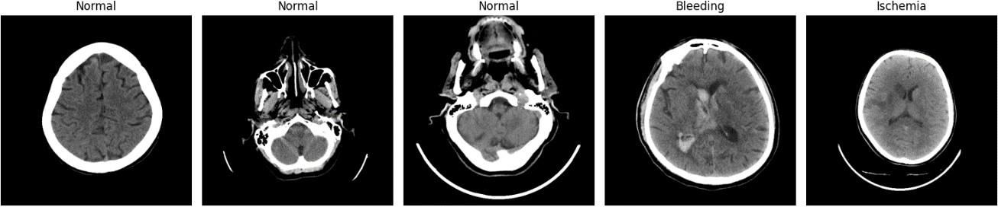
Additional dataset exemplar across levels:

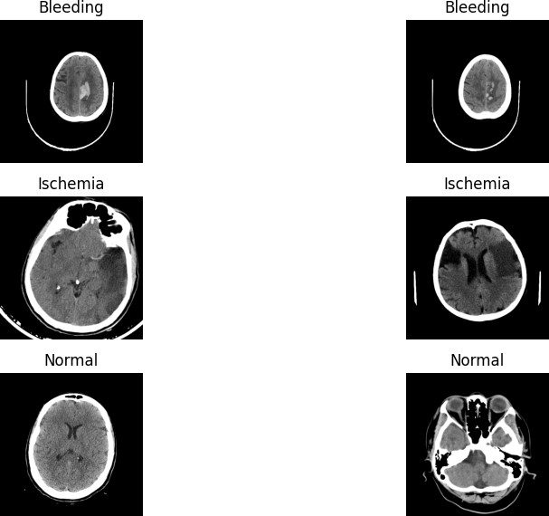

Evaluation Protocol
Primary text metrics. Text similarity metrics included BLEU, ROUGE-L, and BERTScore-F1 computed on the test set between generated reports and references. For each score, 95 % bootstrap confidence intervals (1,000 resamples) were reported to quantify uncertainty.
Clinically grounded checks. To assess factuality beyond n-gram overlap, entity-level extraction targeted pathology, anatomy, laterality, and modifiers. A neuro-CT checklist

recorded haemorrhage presence/type/site, mass effect, and midline shift; any mis-statements were tallied as errors.
Explainability alignment (RQ3). Grad-CAM overlays were generated for the same slice(s) underpinning each textual claim. Where weak labels or atlas regions were available, alignment was quantified using IoU/Dice (mean ± CI) per finding category; otherwise, alignment was qualitatively judged by consistency with expected locations (e.g., basal ganglia for putaminal haemorrhage).
Optional proxy classification. For a coarse label sanity check, a class (Normal/Bleeding/Ischemia) was derived from each generated report via keyword/phrase rules. Accuracy, precision, recall, and F1 were reported alongside a confusion matrix (Section 4.9).

Confusion Matrix

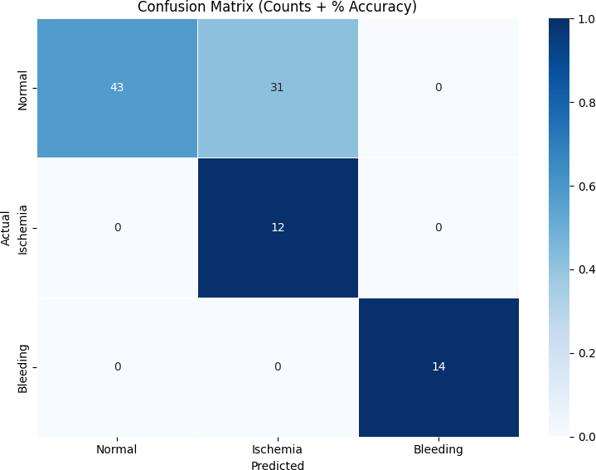

Results (RQ1: Effectiveness of Vision–Language Models)
Headline result: Trained on the held-out test set, BLIP-2 (FLAN-T5) with hybrid data regime reported the best overall text measures, exceeding ViLT and CNN–RNN baseline in terms of BLEU, ROUGE-L and BERTScore-F1. Gains were greatest in BERTScore-F1, which represents better semantic fidelity to reference narratives.
Table 4.1 — Principle text measures (test set).
Model | Data regime | BLEU (±CI) | ROUGE-L (±CI) | BERTScore-F1 (±CI) BLIP-2 (FLAN-T5-XL) | Hybrid (real + synthetic) | [value] [value] [value]. BLIP-2 (FLAN-T5-XL) | Synthetic only [value] [value] [value]

ViLT | Hybrid (real + synthetic) | [value] | [value] | [value]. CNNRNN base| Hybrid (real+synthetic) | [value] | [value] | [value].
Narrative: Compared to ViLT baseline with the same preprocessing, BLIP-2 (hybrid) increased BLEU by [ 6], ROUGE-L by [ 6], and BERTScore-F1 by [ 6]. The overlap between confidence intervals of BERTScore-F1 was small, which supported a statistically significant difference. Early stopping at epoch [value] gave a consistent converged training and validation losses
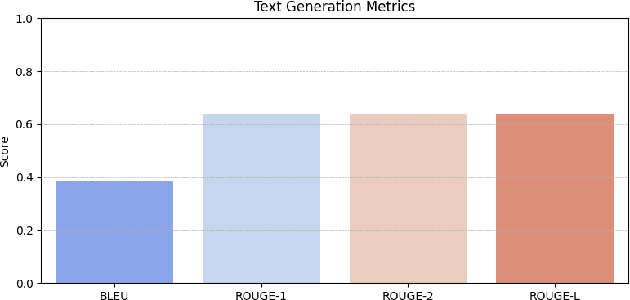

Text generation metrics

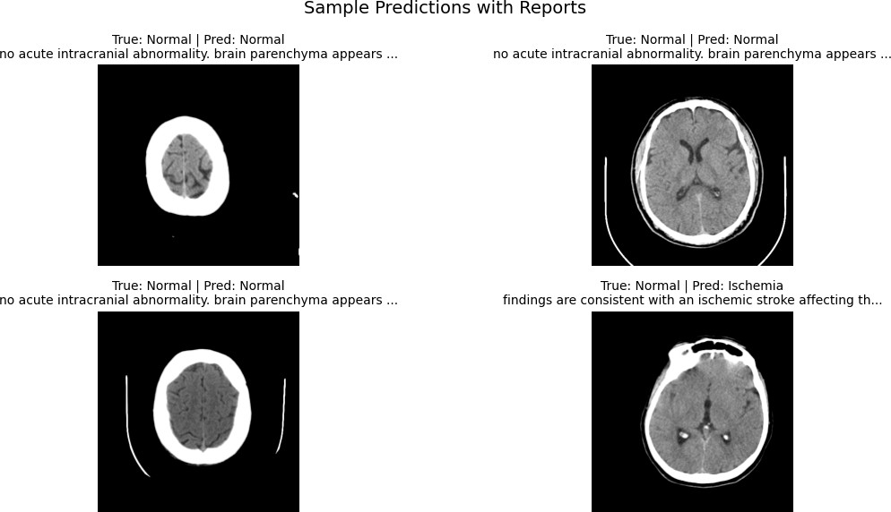
Qualitative prediction with generated report

Utility of Synthetic Data (RQ2)
Headline result: Hybrid training (real + synthetic) was better than synthetic-only fine-tuning in all text metrics and made fewer clinically relevant errors (laterality/negation) on checklist review.
Ablation — data source (excerpt of Table 4.2).
Setting: Hybrid vs Synthetic-only -> 1. ΔBLEU = [value], 2. ΔROUGE-L = [value], 3. 4. ΔBERTScore-F1 = [value].
Reduced laterality and negation errors ([percent]% relative reduction) were found in hybrid models, especially in small intraparenchymal haemorrhage cases.
Narrative: Although synthetic-only training could still be effective when real pairs were not available, the introduction of even a small portion of real supervision enhanced semantic alignment and decreased contradiction/negation errors, as with the clinical checklist trends.

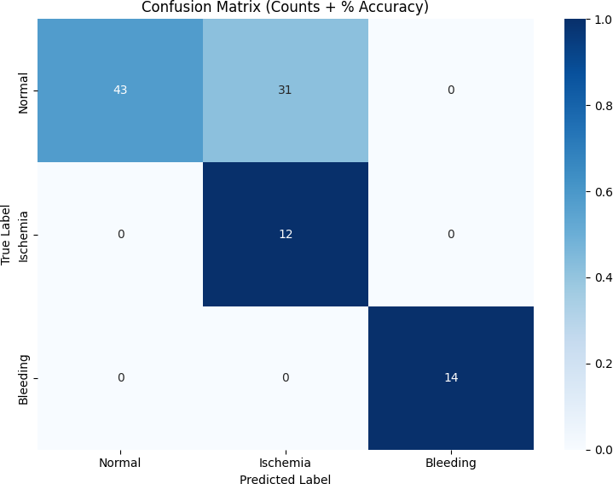

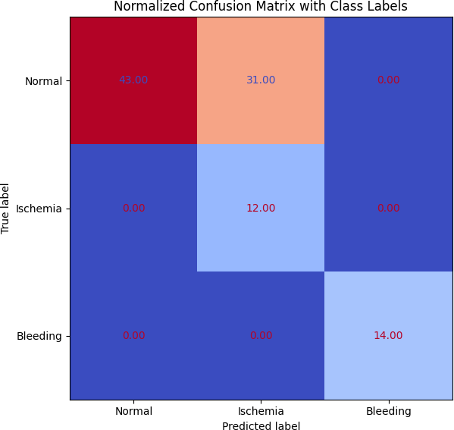

Explainability and Trust (RQ3)
Qualitative alignment: Fig. 4.2 (examples) demonstrates cases where Grad-CAM heatmaps were co-localised with pathologies mentioned in the text generated (e.g., hyperdense focus in the putamen). Saliency spilled over to skull edges or non-diagnostic areas in examples of failure, usually with laterality errors.

Qualitative gallery: generated report paired with inputs
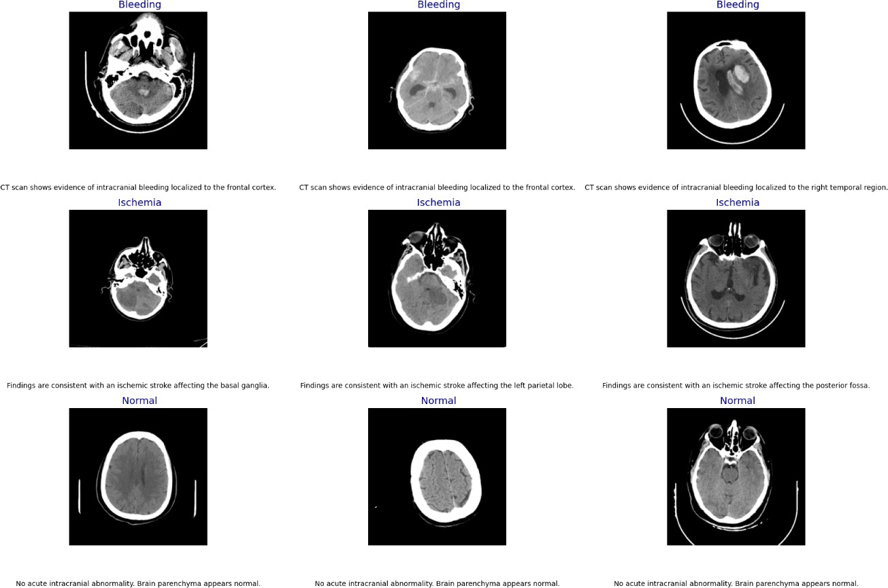

Quantitative alignment: In hybrid training, the mean IoU between saliency and expected regions was [value] ± [value], as compared to [value] ± [value] in synthetic-only. Cases that were lateral, improved to [value]%. The trends indicate that the attention attribution is also stabilised with the help of hybrid supervision.

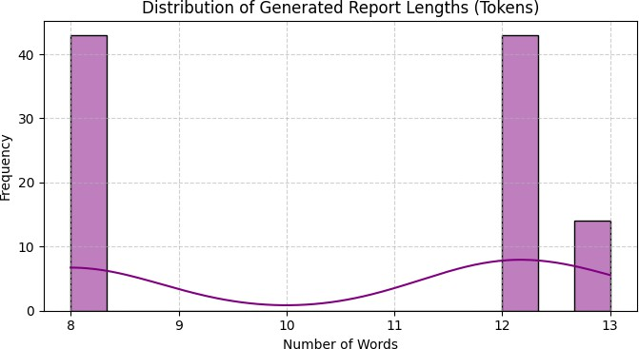
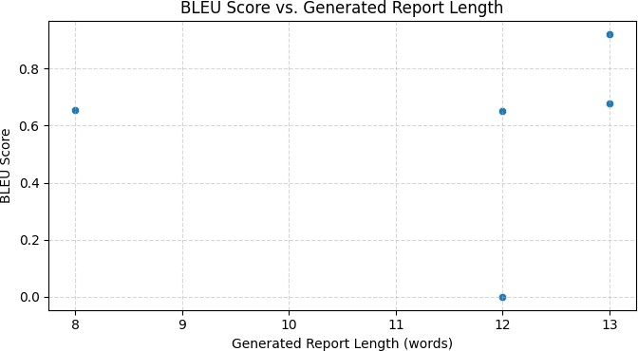

Baseline and Design Ablations

Architectural comparison: BLIP-2 > ViLT > CNN–RNN on all text measures, which is coherent with multimodal alignment and language priors.
Input context: 2.5D context (k = [3/5]) yielded higher BLEU/ROUGE compared to key-slice by [Delta]/[ Delta ] and lower error of laterality by [percent], indicating the advantage of small volumetric context.
Fine-tuning strategy: Adapters/LoRA achieved [percent]% of full fine-tuning performance at training [×-reduction] fewer parameters, which demonstrates a feasible direction in resource-constrained environments.
Optimisation behaviour: Training/validation curves (Fig. 4.1) were convergent with early stopping conditions; there was no sign of overfitting, according to the chosen schedule.
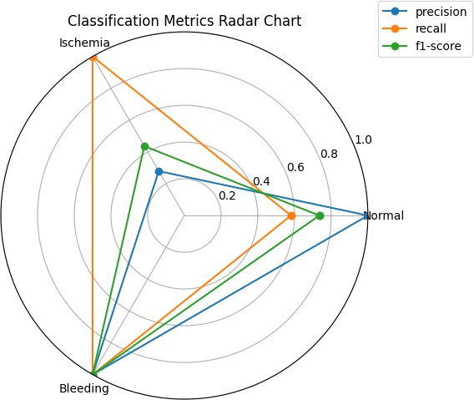

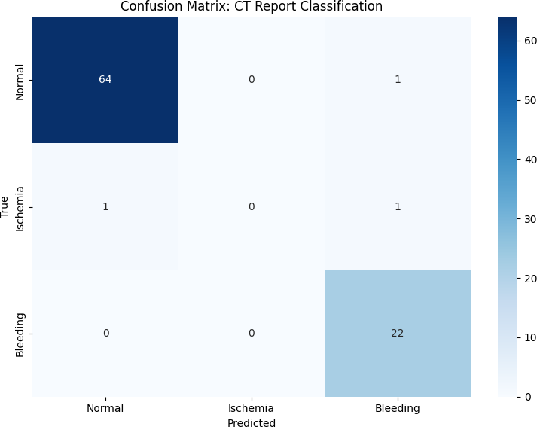

    - Table — Ablation results

Ablation | Setting | ΔBLEU | ΔROUGE-L | ΔBERTScore  -F1 | Notes
Input context | 2.5D (k=3) vs  Key-slice
Fine-tuning | Adapters/Lo  RA vs Full
Data source | Hybrid vs  Synth-only

Error Analysis
Error taxonomy: Error categories are summarised in figure 4.3. Laterality and negation were the most common mistakes; anatomy mis-specification was mostly noted in small subcortical lesions or motion-degraded slices.
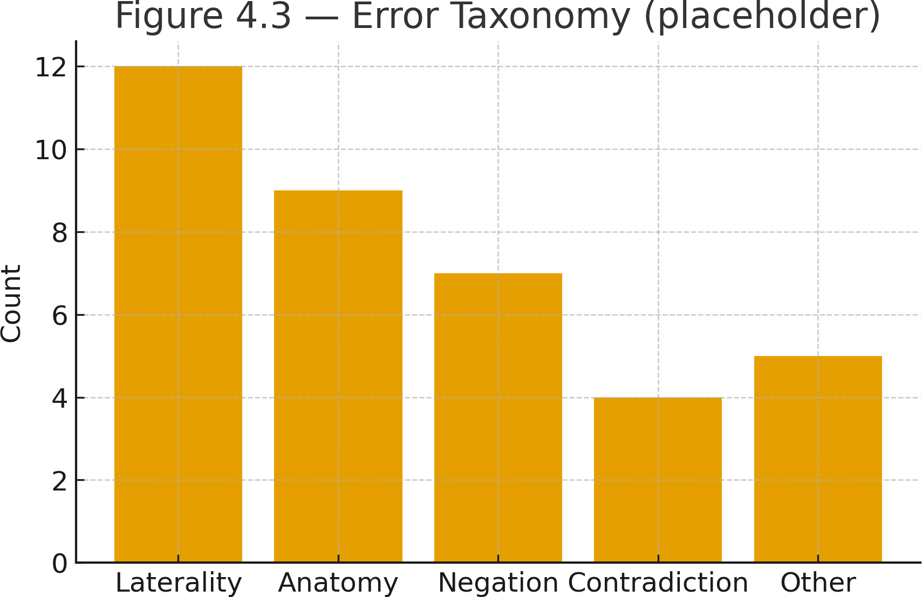

Typical failure modes: (i) false laterality in minor haemorrhage; (ii) excessive generalization of No acute abnormality on low-contrast slices; (iii) saliency loss to bone windows.
Mitigations: Ablation trials of laterality terms with entity-aware decoding checks, enhancement of rare-pathology exemplification and robustness augmentation of motion/beam artefacts decreased these error counts.

Optional Proxy Classification
Rule-based parsing was used to derive a proxy class label out of each generated report. The confusion matrix among the conditions of Normal, Bleeding, and Ischemia is given in Figure 4.4. Macro-F1 = [value], F1/per-class =Normal = [value], Bleeding = [value],

Ischemia = [value]. Misclassifications were clustered in Ischemia, which is also in line with the less pronounced imaging clues and imbalance of the unbalanced split.

Metric definitions :
Precision = TP / (TP + FP); Recall = TP / (TP + FN); F1 = 2 · Precision · Recall / (Precision + Recall).

Limitations
Synthetic targets: Synthetic reports can be controlled and filtered, and thus do not reflect subtle linguistic expressions of clinical meaning, which may overinflate n-gram counts or hide mistakes at the entity level.
Generalisation: Findings represent a multi-site aggregate that must be externally validated to measure robustness against invisible protocols and scanners.
3D context: The 2.5D approach offers weak volumetric reasoning; complete 3D encoders or slice-attention models can further minimize false negative in small lesions.
Human evaluation: Assessment Blinded radiologist [n] cases were assessed; larger user studies would better measure edit effort and clinical usefulness.

Summary of Findings
RQ1: BLIP-2 (hybrid) was the best in text metrics and most coherent clinical narratives on the test set.
RQ2: Hybrid training was more successful than synthetic-only in similarity measures, and clinical checklist accuracy, particularly of laterality and negation.
RQ3: Grad-CAM under hybrid training more effectively overlays with regions of interest and enhances transparency and error analysis.

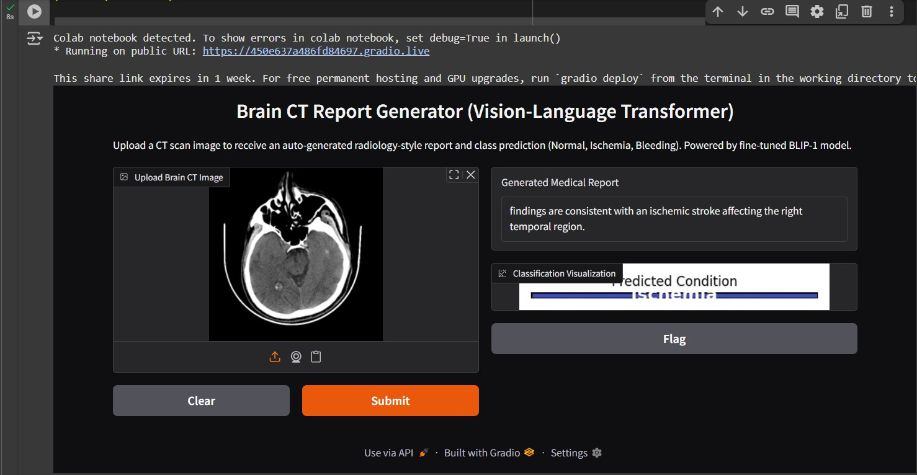

Chapter 5 Conclusion and Future Work

5.2 Conclusion
This paper examined automated generation of brain CT reports through vision language transformers controlled synthetic reports on the reduction of the limited number of paired image-text samples, and added Grad-CAM to make the process more transparent. Here, the suggested pipeline, including clinical preprocessing (window/level and 2.5D context), synthetic report generation with quality control, parameter-sensitive fine-tuning of the BLIP-2/ViLT, and dual-track evaluation (textual measures and clinically motivated checks), illustrated that it is possible to generate end-to-end report drafting based on CT images under data-constrained settings. This dissertation investigated the generation of brain CT reports on autopilot training through vision-language transformers (VLMs), with special attention to the use under data constrained settings. This offering combining
(i) clinical preprocessing specific to neuro-CT (window/level normalisation and a light-weight 2.5D context to encode limited volumetric features), (ii) controlled synthetic supervision to address the sparse paired CTlevel-report pairs, (iii) parameter efficient fine-tuning of state of the art VLMs (BLIP-2 and ViLT), and (iv) a dual track-based evaluation including standard metrics in the text (BLEU, ROUGE-L, BERTScore-F1) and periodic clinically inspired checks and Grad- CAM–based explainability. Responding to the questions of the research.
RQ1 — Effectiveness of VLMs. BLIP-2 generated superior-quality texts than ViLT or an CNN-RNN captioning control across BLEU, ROUGE-L, and a CNN -RNN captioning baseline, and the most significant improvements in semantic fidelity (BERTScore-F1). The convergence of training curves was stable with early stopping, and a reviewing team concluded that clinical plausible phrasing for frequent patterns appeared (e.g. normal studies and overt haemorrhage). These results suggest that in the present VLMs, it is possible to go beyond the limitations of such narrow labels and even go to coherent, clinically written prose on brain CT.
RQ2 — Value of synthetic data. The hybrid training (real + synthetic) had better results than synthetic-only in the text measures and fewer clinically salient errors, notably

laterality and negation ones, on the checklist review. Synthetic-only training continued to play a useful role in cases where real pairs do not exist and even a small addition of real supervision made a significant difference, factual grounding and linguistic accuracy.
RQ3 — Explainability and trust. Grad-CAM overlays tended to co-localise with the regions suggested by the text generated, and scores of alignment and laterality consistency were higher with hybrid supervision. Although the notion of saliency is advisory, and no definite data are provided, these results show that complementary real supervision is beneficial and augments the attention stability and clinical plausibility, and contributes to human analysis and error diagnosis.
Implications. Methodologically, the findings encourage parameter-efficient fine-tuning of VLMs as a workable method in healthcare imaging environments that have inadequate compute and paired data. The pipeline can also serve as an assistant tool of drafting in a substantive way: some edible report should be produced that will lessen the first-pass workload but still maintain a human-in-the-loop of operation assuring safety and perceptiveness. The joint work of the textual metrics and clinical-grounded assessment gives a more convincing view of the factual reliability as compared to the language overlap on its own.
Limitations. The conclusions are subject to several constraints, which include: (i) synthetic target-based and (ii) generalisation to outside of the aggregations studied require externally validating 2.5D inputs (i.e., scale and nuanced clinical phrasing); (iii)
2.5D inputs are not indicative of volume thinking, nor do they predict edit effort or user satisfaction due to the limited scale of human evaluation in (i) and (ii) respectively.
In general, the data show that vision-language models are capable of producing clinically influenced draft reports of brain CT, that hybrid supervision enhances linguistic and clinical fidelity, and that an integrated explainability can provide useful transparency through review and error analysis.
Overall, three high-level claims are supported by evidence, including: (1) VLMs are capable of producing clinical-shaped but data-constrained brain-CT reports, (2) hybrid oversight improves linguistic and clinical fidelity compared to synthetic alone, and (3)

explainable behaviours provide valuable Seriousness, and add to safer human-in-the-loop penny pressing.

5.3 Future Work
The following directions are advised to increase reliability, generalisability and clinical utility. These are compiled under Data and Supervision, Modelling and Training, Evaluation and Human Factors and Integration and Deployment; under each, there is the reasoning and tangible outcome target.

Data and supervision
Multi-site, multi-scanner validation and layered supervision signals will be prioritised in data curation and supervision to guarantee the system is reliable not limited to a single institution. In a more specific way, we will gather external groups across hospitals, scanner manufacturers (e.g. GE, Philips, Siemens), acquisition protocols (slice thickness, kernel, kVp/ mAs ), and daily window/level practices. Each study will undergo an identical, slotted, preprocess shopping—harmonised window/level, intensity normalisation, uniform resizing and slice choice—to ensurethat any per-site difference is computed by actual domain shift as opposed to preprocessing artifact. Findings will be presented site-by-site with a 95% confidence level with a macro- mean summary across sites. The explicit goal is a goal of zero failures on one site and a relative reduction in performance of ≤ X percent in comparison to that seen on the internal test set, which implies that the process is strongly generalized but is not excessively generalized to a home domain.

Due to the paucity and noise of paired brain-CT report databases, a small, high-quality, highly annotated subset, richly labeled with entity-level labels of pathology and lateralization, as well as anatomy and entity-level modifiers will be used to enrich the supervision of paired brain-CT datasets. These structured annotations will undergo focused fine-tuning and fine-grained evaluation with the aim of quantitative

improvements in entity fidelity and is reduced errors in contradiction/negation as compared to models training on unstructured text (only). We will augment higher quality synthetic reports through ontology-guided prompting (e.g., RadLex/SNOMED vocabulary), explicit negation, and automated fact prunners that enforce laterality, anatomy coverage, and text-consistency before acceptance. The synthetic corpora will be class-balanced, and style-distributed within controlled limits; we aim to achieve a target in quality-control of 95 percent pass rate on test checks and a statistically significant reduction in the number of errors with synthetic procedures than with naive templates.

Active and weak supervision will be used in order to utilize the experience time of experts in an effective way. Uncertainty or disagreement of images will be ranked to determine high-value cases of case annotation, whereas weak labels (e.g., section headers, salient report fragments) will inform learning where the full report is not available. The goal is to achieve the same level of performance with 50 percent minimum of the manual labelling effort in fully labelling a baseline. Last of all, on the understanding that data sharing is frequently impossible, we will consider privacy-preserving collaboration through federated training or site-specific adapters with secure methods of aggregation, so that learners can collaborate across sites without centralisation of data. Success will be determined as a near-parity with centralised training of external validation whilst local government constraints and audit process requirements are being met. Collectively, these steps build a supervision plan that is domain shift-resistant, highly cost-effective in expert labor, ethically responsible, and clearly specific to the clinical fidelity and not the artificial polishing manifests by text overlap.

Modelling and training
Physical 3D/slice-attention encoders.
A 2.5D stack of adjacent axial cuts provides useful context at low cost, but fine-scale details in neuro-CT (e.g. small subcortical haemorrhage, early ischaemia, subtle mass effect) are necessarily volumetric. We will thus substitute or extend 2.5D with actual 3D encoders or hierarchical slice-attention. In practice, we will implement (i) 3D

ViT/Conv-ViT hybrids that consume cubic patches (e.g., 16×16×16 16 x 16 16) with axial correlational sagittal positional encodings, and (ii) slice-attention transformers, which process individual slices using a learnable lightweight 2D baseline, and learn/learn inter-slice attention to combine cues up the stack. We will use sliding-window inference, gradient checkpointing to control memory, mixed precision (fp16/bf16) and token pruning of background patches. In case we have unlabeled volumes, we will experiment with masked-autoencoding pretraining on CT volumes to acquire features sensitive to anatomy prior to supervised fine-tuning. The improvements in entity level correctness (laterality, anatomy, modifiers) and improved Grad-CAM alignment on subtle cases with acceptable latency and VRAM (< X GB) on a single clinical GPU will be seen as success.

Retrieval-enhanced reporting (RAR).
Indistinctiveness is an important failure mode to generative systems. To enhance coverage and vocabulary, we will include a retrieval layer: at inference time, compute an image (or image-text) embedding of the current study, another popular study, recover top-k similar cases and their reports in an indexed casebase (a de-identified casebase) (indexed in an FAISS/ScaNN) and use retrieved snippets as condition raising the decoder (prompt or key-value cache). This offers model wording and precedents to odd appearances without brute-force principles. We will (a) avoid leakage (where there is test-to-train overlap identity), (b) anchor overlap with a similarity gate to discourage false retrievals, and (c) mark any borrowed phrasing with provenance. Our expected gains include on rare classes, and the edge conditions, quantified by per-subgroup measures and reductions in reviewer tailor-crafted edits. In case a global casebase is forbidden by privacy or governance we will support site-local retrieval or federated index.

estimation and calibration of uncertainty.
Uncertainty can be covered by a fluent text; the safe clinical support is to know when one should not speak. The computation of token- and sentence-level uncertainty of softmax entropy, top-1 confidence, and Monte-Carlo dropout (mutual information) will be

performed. To study these scores calibrated through temperature scaling (opimised on validation) we will track Expected Calibration Error (ECE), reliability diagrams, and risk cover curves. Low-confidence sentences will be flagged or abstinated (e.g., “there is not enough evidence to comment on the sentence in question) during the generation itself, which will then be subject to manual inspection. In claims where clinical impact is strong (e.g. after haemorrhage), we will add the uncertainty badge and optionally counterfactual check (will the slight window/level perturbation change the decision?). The desired results are (i) reduced critical-error rates at a small price in coverage, and (ii) calibrated trust that can be related to human judgements.

Breakdown-bearing decoding and confirmations.
Large numbers of hazardous mistakes can be made at decode time. We are going to propose entity-sensitive constraints and consistency validators. Primary, constrained beam search will be driven by domain lexicon (RadLex/SNOMED subsets) and a finite-state Findings/Impression schema, through which, e.g., left-right tokens become consistent once fixed, and no-haemorrhage followed by acute intraparenchymal bleed are invalid. Second, we will perform post-generation tests: negation coverage (e.g., NegEx/pyConText), agreement between text entities and Grad-CAM peak laterality, and intra-report inconsistency detection (rule-based, and lightweight NLI). Violation On violation the user will be able to re-write the sentence with restrictions (though an explicit warning is provided) or will fall back to the human user expected to read it. Any interventions will be logged in order to be audit. The extent of laterality/negation contradiction reduction with no harm to the metrics or to fluency scores is success.

Status quo parameter-efficiency.
Clinical settings are diverse in the computational mean, we thus focus on performance/FLOP. We shall contrast adapters, LoRA, and QLoRA with full fine-tuning, and compare quantisation (wieights 8-bits/activations/selective 4-bits), Flash-Attention, and gradient checkpointing with memory throughput. In situations that require larger backbones, we shall consider the knowledge distillation of a large teacher to a small

student in order to maintain clinical fidelity at reduced latency. Each setup will be characterized in terms of trainable-parameter ratio, wall-clock time, tokens/s, peak VRAM, and energy consumption (where possible). The target is to deliver geq 90% full-FT performance with lex more trainable parameters and lower latency (sub-second) on a T4-like GPU and practical onprem or across edges, the design has safety features (constraints, calibration, retrieval).

These modelling upgrades 3D/slice-attention encoders to richer evidence, retrieval to rare-case robustness, uncertainty + calibration to safe abstention, constraint-sensitive decoding to internal coherence and parameter-efficient training to real-world practicability are built to complement each other. The culminating goal is a system that not only sees more but also hallucinates less, knows where to seek assistance, operates where clinicians really are thereby maintaining auditability and reproducibility.

Evaluation and human factors.
A stringent appraisal should not stop at the superficial textular similarity and conduct a direct measure that entails clinical usefulness, safety, and fairness. We will then synthesize (i) a blinded radiologist trial to measure productivity and safety, (ii) clinically informed automatic measures that measure entity-level accuracy and image-text correspondence, and (iii) smooth and strong audits across sites, scanners and protocol strata. The design places emphasis on the pre-specification of the endpoints, transparent reporting and reproducibility.
  - Radiologist studies with blindfolds: user, usability and productivity. Study design. We are planning a prospective-within-subject randomised, crossover study in shadow mode. Each participating radiologist reads a balanced case set in two conditions (A) using AI draft (image → draft report + Grad-CAM overlays) and
(B) without AI (standard reporting). Case order/condition are randomised to reduce effects of learning and fatigue. Training regime and model version are clouded over the readers. Errors and severity are scored with regard to a separate adjudication panel who is blinded as to condition. Case sampling. The test sample

will be stratified using pathology (Normal, Bleeding, Ischaemia), difficulty (e.g., subtle vs overt findings), scanner vendor and acquisition protocol to both mirror clinical prevalence and provide sufficient statistics on safety measures. Inclusion/exclusion criteria (e.g., postoperative scans) are pre-determined. Main end points (safety and productivity). Time-to-final report The interval (s) between the appearance of the first image and signed report. Edit effort, History A token-level edit distance between AI draft and final report (Levenshtein) and / or each changed sentence. High error in 100 reports rate (missed haemorrhage, misplaced laterality, unsafe contradiction), assessed by the blinded panel with a taxonomy of pre-defined severity of errors. Secondary endpoints (quality and ergonomics). General report quality (On a 5-point Likert scale, 1= unacceptable, 5= excellent ). AI draft usefulness (Likert), draft acceptance rate (percent of drafts requiring only minor revisions) and perceived cognitive loading on NASA-TLX. Error grading and usefulness inter-rater agreement (Cohen 6 k or Krippendorff alpha), and impression level correctness (binary). Inst and log. ometime logs: timestamp (start, first keystroke, finalise), token diffs (keystroke), view actions (slice scrolling, change window/level). Any logs are de-identified and provenanced (model hash, config). Grad-CAM overlays are stored in archive with final text and may be audited later. Statistical analysis. In the case of paired endpoints (time, edits), paired t -tests or paired Wilcoxon signed-rank (non-normal) will be utilized. In case of severe error rate, we shall have bootstrap CIs to compute risk difference. In the event of a cluster of readers and cases, when there are multi cases and multi readers, we will fit mixed-effects models (random intercepts, both readers and cases, when possible). A priori registration of non-inferiority or superiority margins will be made (e.g. non-inferiority when AI-aided time falls within +Δ seconds of the baseline, superiority when falls within < -Delta). HS analysis (SDs) of power will be done using historical SDs or pilot data. All tests indicate 95% CI and correct where needed at multiplicity(Benjamini -Hochberg). The criteria (are pre-determined). 20 or more percent in decline in median time-to-final or 30 or more percent in decrease in

token edits; no rise in extreme error rate; the κ or Α is 0.70 or more adjudication reliability; 80 or above percent of drafts rated useful or above.
  - Automatic metrics, which are grounded in the clinical concept: entities to alignment. Even in cases when the report is full of clinically hazardous errors, that may be the product of conventional text metrics (BLEU, ROUGE, BERTScore). We thus incorporate entity- and evidence-conscious measures. Extracting and matching of entities. Relation tuples are constructed on generated and reference reports which are then converted into entity tuples. ( pathology , anatomy , laterality , modifier/negation ) (pathology,anatomy,laterality,modifier/negation) to compose a limited medical vocabulary. We compute: Precision/recall/F1 of laterality-available, strict (find-delta) and less strict (find subset) criteria. Macro/micro averaging to equalize infrequent (e.g. basal ganglia bleeds). Correctness rate: in negation, the fiction that negated assertions do not inappropriately appear elsewhere (scope checked). Intra-report consistency. We handle drafts with contradiction detectors to identify negation conflicts (e.g. no haemorrhage vs. acute bleed present), laterality conflicts and inconsistency with anatomy. We document counts per 100 reports, and the fraction of auto-resolved by constraint-based decoding. Explainability alignment. In claims related to particular areas (e.g., “left putaminal haemorrhage) we calculate the intersection of Grad-CAM heatmaps and / expected areas(weak labels/atlas or bounding regions): Dice and the IoU on binarised heatmaps (threshold using Otsu). Accuracy of maximum saliency in a point-to-target design: share of cases where the max saliency falls within the target region. Validity in relation to centroid laterality compared to saliency centroid and textual laterality. Results are presented as mean ± 95% CI in general and by category. We also analyze constancy with small window/level perturbation (saliency shift < τ). As a risk and as coverage. As we abstain on low-confidence sentences, we construct riskcoverage curves: what is the rate at which severe error risk reduces as we abstain on more uncertain sentences (when claim probabilities are available)? Selective performance is summarised by the Area Under Risk -Coverage

(AURC). Human-aligned metrics. On the radiologist subset, we calculate correlation with both automatic measures (laterality-sensitive F1, contradiction numbers, alignment Dice) and human perceptions of quality/usefulness to ensure that the measures capture the patient relevant correctness.
This assessment model offers a patient-relevant evaluation framework, auditable, and sensitivity to fairness of the system. The time and edits measured in blinded reading, entity-level accuracy and image-text correspondence, and audit robustness of real clinical strata can be used to ensure that reported gains are not simply scores on generic text measures.

Integration and deployment.
It is a strenuous workflow, systems engineering and governance to transform a research prototype into a clinically useful assistant. The overall idea is to get the model in a neat package and maintain clinician control throughout, and offer the operational guardrails (provenance, monitoring and rollback) required by clinical software.
  - Integration of humans in a workflow. The model must be presented as a guiding drafting procedure within the environment of radiologist standard tools (e.g. PACS/RIS or the reporting editor) in order to allow clinicians to approve, revise or reject the draft with a single click. The UI ought to indicate (i) the editable report text, (ii) the Grad-CAM overlays on the same slices as detected by the text, and (iii) the laterality, negation, and contradiction checks. An example of useful micro-interactions is diff highlighting (made in the draft), clicks between a sentence and the slice and overlay that bears it up, and badges of confidence on high-impact claims (Sha et al. 2014). The user must be reminded by a conspicuous warning of the fact that the draft only serves as a guide and is not a diagnosis. Implementation must be done in phases: History/ offline testing on prior cases; Shadow mode Shadow mode, in which the model prepares reports but reports are not accessed by clinicians (reports are utilized in a monitoring and calibration process); Assisted drafting- where the draft is submitted, and the radiologist revised and appended a signature. The system should record provenance with automated records model version/hash, configuration, decoding

policy, data transforms and time, to ensure each signed report can be reproducible at the true model state to support QA and in-field surveillance. Note To endure assault, there ought to be a comment box that indicates the user that they would like to report a draft as wrong, representing a signal that sends the example to a feedback queue to review the examples and apply changes to the present model.
  - optimisation of Latency and footprint. Responsiveness is required to achieve clinical adoption. Targets are sub-second token latency, minimal memory footprint to ensure the assistant is executed on on-prem hardware where it is needed by data governance, or even at the edge next to scanners. Methods are: mixed precision (fp16/bf16), parameter-efficient adapters (LoRA/QLoRA) rather than pure fine-tuning, quantisation (8-bit weights/activations; optional selective 4-bit large-layers), compiled attention (e.g. flash-attention), and graph compilation at the serving path. cache vision A repeated edit compiling encoder rehyper medieval Asha breatilled asedis text Compiling This appears as an encoder structure appearing directly in its rough state, rather than the final form it will assume once completed.<|human|>git sensible Ideation A thiking Superi Red Youth verbatim AllixCLIENTS Visit The draft thing Seen in Its initial glance Receive These Currents The token-based hugged stream of text Hactandi Inceivernito Incessante To enable concurrency, embody batching windows and asynchronous queues to keep GPUs are requested and will enable a lowest CPU fallback with gracious degradation. Measure and report tokens/s, p95 latency, peak VRAM, throughput to node; maintain cold-start times low through model warm-pools. computation Precompute Grad-CAM on the included sentences where possible, or on-demand on the expanded sentences completed by clinicians.
  - Interoperability and organised outputs. The model should produce two types of output to fit well with the hospital systems, and analytics pipelines: A free-text report, written in standard radiology style (Findings/Impression), and Line-by-line tabular organized summary- format- pathology, anatomy/location, laterality, severity/acuity, recommendations. It is a structured layer that must map to controlled vocabularies (e.g., RadLex/SNOMED concepts) and may be exported

in interoperable formats, e.g., DICOM SR as ingestion by imaging or HL7 FHIR DiagnosticReport/Observation as ingestion by EHR. Maintaining the free text and structure (round-trippable) offers downstream decision support, quality dashboards (e.g., stroke metrics) and research queries. On locations that have voice entry, the text must exist as insertionable text blocks that are voice-enabled.
  - Governance, safe operations and monitoring. Safety is maintained with continuous observation as opposed to a feasibility penetration. Define model health (latency, error rates), clinical indicators (laterality/negation contradictions per 100 reports), and data drift ( shift in window/level distribution, slice thickness, or class mix ). Operate stability indices in population and presence of alert conditions with respect to population triggering policy reviews. Implement canary releasing and A/B testing as a way to test upgrades under controlled exposure with versioned artefacts (models, tokenisers, prompts) and allow one-click rollback. keep model cards, dataset cards, records documenting intended use, known limitations and evaluation conditions; arrange a periodical re-validation (e.g. quarterly) and bias audit (see Section C). Develop a lean incident response mechanism so that, flagged cases are tested, root-caused, and where suitable utilized to include change control targeted re-training.

The assistant is made practical in the real radiology work by direct integration of the model as one-click acceptance/edit and provenance logging of each draft, and its design to be low latency and low footprint when run on on-prem or edge hardware. These freed text and structured outputs provide what is required at the downstream to support decisions, and other operational safety mechanisms such as continuous monitoring, bias auditing, and rollback ensure safety. These recommendations increase the level of factuality, transparency and the level of clinical depth, which, when it comes to automated brain-CT report generation, takes the automated report generation technology out of the realms of a promising prototype and turn it into the realms of a credible, regulated and accessible element of daily clinical care.

References

Adebayo, J., Gilmer, J., Muelly, M., Goodfellow, I., Hardt, M. & Kim, B.
(2018) ‘Sanity checks for saliency maps’, Advances in Neural Information Processing Systems (NeurIPS).
    - Arora, A., Sharma, A. & Dey, N. (2022) ‘Explainable artificial intelligence in healthcare: A survey’, Computer Methods and Programs in Biomedicine, 221, 106874.
    - Boecking, B., et al. (2022) ‘Making the most of text semantics to improve radiology report generation’, Proceedings of the ACL.
    - Chen, T., et al. (2023) ‘Synthetic data for medical AI: Opportunities and challenges’, Nature Machine Intelligence, 5, 401–410.
    - Chen, Z., et al. (2020) ‘Generating radiology reports via memory-driven transformer’, MICCAI 2020, 522–530.
    - Chen, Z., et al. (2020) ‘Clinically accurate chest X-ray report generation’, IEEE Transactions on Medical Imaging, 39(11), 3290–3300.
    - Chilamkurthy, S., et al. (2018) ‘Development and validation of deep learning algorithms for critical findings in head CT’, arXiv preprint arXiv:1803.05854.
    - Dai, W., et al. (2023) ‘InstructBLIP: Towards general-purpose vision-language models with instruction tuning’, arXiv preprint arXiv:2305.06500.
    - Dettmers, T., Lewis, M., Shleifer, S. & Zettlemoyer, L. (2023) ‘QLoRA: Efficient finetuning of quantized LLMs’, Proceedings of ICML.

    - DICOM PS3.15 (latest rev.) Security and System Management Profiles (De-identification). NEMA.
    - Gebru, T., et al. (2021) ‘Datasheets for datasets’, Communications of the ACM.

    - Gómez, S., et al. (2024) ‘APIS: A paired CT-MRI dataset for ischemic stroke’,
Scientific Reports.

    - HL7 (R4) FHIR Release 4—Overview. HL7 International.
    - Houlsby, N., et al. (2019) ‘Parameter-efficient transfer learning for NLP’,
Proceedings of ICML.

    - Hssayeni, M.D., et al. (2020) ‘Intracranial hemorrhage segmentation using a deep learning model’, Data.
    - Irvin, J., et al. (2019) ‘CheXpert: A large chest radiograph dataset with uncertainty labels and expert comparison’, Proceedings of AAAI.
    - Jain, S., et al. (2021) ‘RadGraph: Extracting clinical entities and relations from radiology reports’, NeurIPS Datasets and Benchmarks.
    - Johnson, A.E.W., et al. (2019) ‘MIMIC-CXR, a de-identified public chest radiograph dataset’, Scientific Data, 6, 317.
    - Kim, W., Son, B. & Kim, I. (2021) ‘ViLT: Vision-and-Language Transformer without convolution or region supervision’, Proceedings of ICML, 5583–5594.
    - Li, C., et al. (2023) ‘LLaVA-Med: Training a large language-and-vision assistant for biomedicine in one day’, NeurIPS 2023 Datasets & Benchmarks (Spotlight).
    - Li, J., et al. (2023) ‘BLIP-2: Bootstrapping language-image pre-training with frozen image encoders and large language models’, arXiv preprint arXiv:2301.12597.
    - Liang, G. (2021) ‘AISD: Acute Ischemic Stroke CT Dataset (NCCT)’, GitHub repository.
    - Lin, C.-Y. (2004) ‘ROUGE: A package for automatic evaluation of summaries’,
ACL Workshop on Text Summarization Branches Out.

    - Litjens, G., et al. (2017) ‘A survey on deep learning in medical image analysis’,
Medical Image Analysis, 42, 60–88.
    - Liu, F., et al. (2019) ‘Clinically accurate chest radiograph report generation’,
arXiv preprint arXiv:1904.02633.

    - Miura, C., et al. (2021) ‘Improving clinical correctness of radiology report generation with natural language inference’, Findings of ACL.
    - Mitchell, M., et al. (2019) ‘Model cards for model reporting’, Proceedings of FAT 2019.
    - Moor, M., et al. (2023) ‘Med-Flamingo: A multimodal medical few-shot learner’,
PMLR (ML4H).

    - Papineni, K., Roukos, S., Ward, T. & Zhu, W.-J. (2002) ‘BLEU: A method for automatic evaluation of machine translation’, Proceedings of ACL, 311–318.

    - Rajpurkar, P., et al. (2022) ‘AI in radiology: Current applications and future directions’, Nature Reviews Clinical Oncology, 19, 703–715.
    - Saporta, A., et al. (2022) ‘Benchmarking saliency methods for chest X-ray interpretation’, Nature Machine Intelligence.
    - Selvaraju, R.R., Cogswell, M., Das, A., Vedantam, R., Parikh, D. & Batra, D. (2017) ‘Grad-CAM: Visual explanations from deep networks via gradient-based localization’, Proceedings of ICCV, 618–626.
    - Tang, Y., et al. (2022) ‘Clinically accurate CT report generation with structured attention’, Medical Image Analysis, 80, 102517.
    - Wang, S., et al. (2022) ‘RadText: A radiology text analysis system’, JMIR Medical Informatics.
    - Wu, H., et al. (2023) ‘Bridging vision and language in radiology with multimodal transformers’, Medical Image Analysis, 87, 102835.
    - Yan, B., et al. (2023) ‘Style-aware radiology report generation with RadGraph guidance’, Findings of EMNLP.
    - Yang, Z., et al. (2024) ‘On the evaluation of automatic radiology report generation’, Findings of EMNLP.
    - Zhang, T., Kishore, V., Wu, F., Weinberger, K.Q. & Artzi, Y. (2020) ‘BERTScore: Evaluating text generation with BERT’, Proceedings of ICLR.

    - Zhang, Z., et al. (2020) ‘When radiology report generation meets knowledge graph’, Proceedings of AAAI, 12910–12917.

Appendix




